**Arab Open University- EGYPT**



**Faculty of Computer Studies**

**Information Technology and Computing Department**

***GARAGE***

**TM471**

**Supervisor:**

**Dr. /** **Mustafa Abdul-Salam**

**Presented by:**

**Nader Mohammed Galal Eldin Tawfik**

**ID:**

**1851710334**

**Table of content:**

**Title page**

**Chapter 1 ……………………………..……………………3**

**introduction………………………………..3**

**motivation………………………………….5**

**CHAPTER 2.……………………………...6**

**Literature Review………………………6**

**CHAPTER 3...…………………………….……………….9**

**1 Requirements and Analysis…………9**

**1.1 Software requirements………….9**

**1.2 Hardware requirements………….9**

**2 diagrams………………………..……………………..10**

**Class diagram……………………….10**

**Use case diagram……………………11**

**Activity diagram…………………….12**

**CHAPTER 4...……………………………………..………..14**

**CHAPTER 5...………………………..……………………..46**

**5.1 Introduction………………………………..…46**

**5.2 Strategy of evaluation…………….…...……..46**

**5.3 Methods of evaluation……................……..…46**

**5.4 Android application evaluation…..………….47**

**5.5 Android application questionnaire……….....47**

**5.6 Results Evaluation ………………….…..…...49**

**5.7 Future Application…………….…………..…50**

**Chapter 6 Conclusions…………………………….51**

**Results…………………………..53**

**Chapter 1: Introduction**

**1.1 Introduction to the project.**

* Seeking a vacant parking space during peak hours in areas like Hospitals, Hotels, Airports, Universities, has always been frustrating for many drivers. Surveys says that traffic generated by cars searching for vacancies in Parking Spaces is up to 40% of the total traffic.
* Now that is a serious issue to look after, and Smart Parking System is one of the best available solutions to at least reduce the traffic congestion caused due to the above problem.
* This application gives information about the occupancy status of the spaces in the parking lot (**Garage**).
* (**Garage**)is an Internet of Things (**IOT**) based application, used to detect the available and nearest parking slots. Based on the parking slot occupancy, the status (occupied/unoccupied) is displayed on mobile application.
* the vehicle drivers can search for parking availability using their mobile phones or any infotainment system that is attached to the vehicle.
* Hence the driver would know where there is an available spot to park his vehicle in less time, reducing the energy consumption and air pollution.
* The most important topics is to reduce street congestion and obstruct traffic and keep the car from being stolen or scratched.

**The second part in this application:**

* Is doing analysis on parking trends in a parking lot. The analysis gives information about which parking space is most occupied and least occupied and at what times of the day. This information is helpful in choosing one parking space when there are multiple available, keeping in mind the history of that space.
* The user determines the location of the parking lot in which he wants to park and determines the time taken to park his car, and based on that, the price of the parking cost is calculated.

**How do the App work?**

There are six main steps:

1. **Searching**. The user locates the car using GPS or enters the necessary address.
2. **Comparing**. The app provides several variants of parking spots. The user can filter them by price or distance to find the perfect match.
3. **Booking**. The driver reserves the selected parking space and gets an access code.
4. **Paying**. The user can pay by credit card in advance or in cash later.
5. **Driving**. The parking app offers driving directions to the parking lot.
6. **Parking**. The driver enters the parking lot and parks the car.

**1.2 Motivation**

This smart parking system helps drivers make smart decisions that reduce congestion and make the most of available space. Finding a parking space has become a daily concern these days, and this is where the motivation for this project was born. With the advancement of technology, we have smartphones and a centralized management system that displays this employment status in an app (GARAGE) to help drivers find a free places.

**CHAPTER 2 – Literature Review**

First of all, the application is aimed at drivers, and its key goal is to help them find the best parking spots without wasting time. What features should we consider to achieve this goal?

**Some features will be added and not used in similar apps:**

* Registration & Authorization. There are many ways to register, including through social networks, but in the case of the parking reservation app, it's imperative to take appropriate security measures and verify the user (SMS code).
* List of vehicles. The feature isn’t a must-have, but it is desirable. The driver must be able to add a list of his cars with an indication of the details of each (car model, state number).
* Map. It’s about a special navigation screen, which displays a city map with marked parking lots.
* Parking Search. Of course, it's important to provide the driver with the opportunity to find one of the nearest public parking spaces. It's also great if your parking spot finder app can get directions to any location the driver chooses.
* Parking spot details. To finally decide on the choice of parking, the driver must be able to learn the details of every place: the price per hour, its location, the number of parking spots.
* Parking spot booking. Everything is clear here, isn't it? The feature would be especially useful if the driver wants to pre-select and book a convenient parking spot to leave his car in the near future (more precisely, in the time interval he sets).
* Payment. Let’s say, the driver has parked his car; now it's time he paid for the provided service. Hence, your parking management software cannot do without a secure payment solution.
* Parking history. driver may find it helpful to recall where and when he used to park his car in the past (and how much he paid in each case).
* Reviews & Ratings. Choosing a place to park the car would be even easier if the user can find out the opinion of other motorists about a particular parking zone. This means you need to provide an opportunity to leave feedback and set a rating.
* booking the slot in advance by adding additional cost to the pre booking.
* Notifications. Of course, it would be helpful to keep users informed of what is happening and send them all kinds of notifications. What to inform drivers about? There are many options, such as:
  + - * warning that parking time will expire soon;
* informing on changes in the conditions of use of a particular parking lot;
* a reminder that you need to renew your subscription;
* Favorite parking lots. Let drivers add frequently used car parks to the “Favorite” category. Then the user would be able to see these spots on the map marked with a different color (or in another way).
* Settings. And the last mandatory item on our drivers-focused list of features of parking apps should be Settings. Drivers will be happy with the opportunity to choose the UI language, change personal data

**CHAPTER 3 – Requirements and Analysis**

**1 Requirement Specification**

The technical requirements to develop Smart Parking System application.

**1.1 Software Requirement:**

* Operating System, Smart phone.
* IDE: Android studio.
* Programming languages: Java, android.
* Database: Firebase.

**1.2 Hardware Requirement:**

* Pc, Android smart phone
* Processor: Intel Core 2 Duo or Higher
* RAM: 4GB

**2.1 Class diagram:**

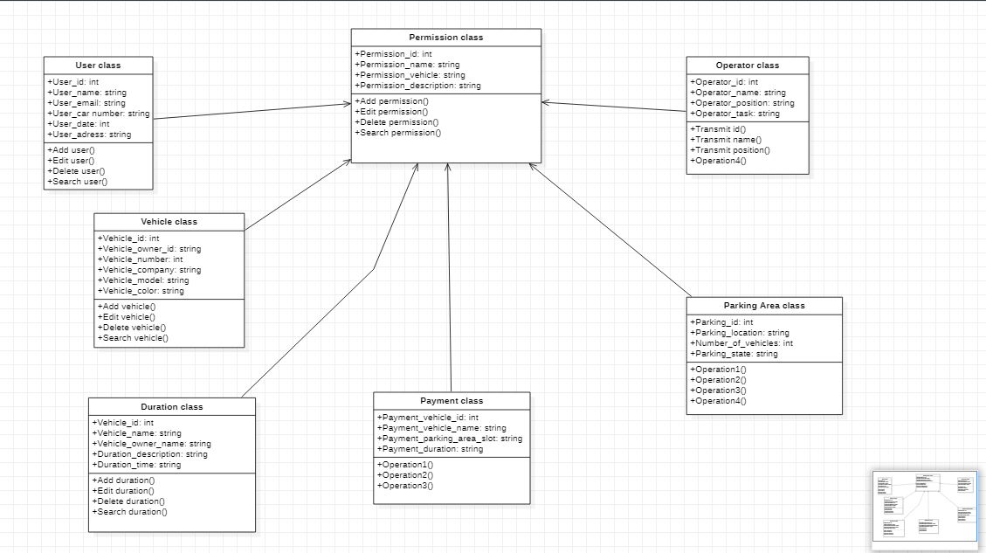

**2.2 Use case diagram for parking app:**

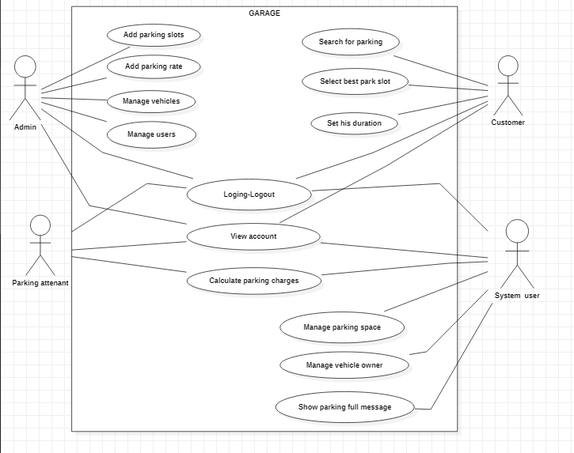

**2.3 activity diagram:**

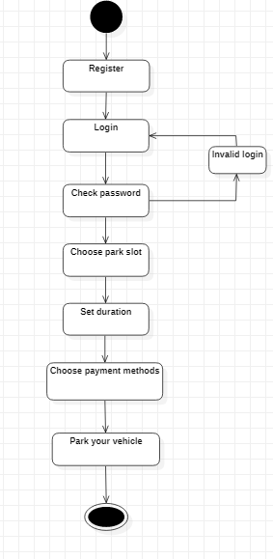

**Chapter 4: Design, Implementation and testing**

**Software development approach:**

* For the mobile app implementation, Android Studio was considered. The software development was performed using the ASP.NET Microsoft Visual Studio framework, while the database was implemented using Firebase.
* The User of the system is a vehicle driver who would be searching for a vacant parking space, and that provide something of measurable value to the user like checking the parking lot for vacant spaces,
* checking the parking history to find he most occupied and less occupied parking slot.
* Finally after finding a vacant space, he can park his vehicle.

**There are three stages we worked on it:**

1. **Developing a required analysis:**

**By designing and developing a class diagram, use case diagram and UML Diagram that is followed during developing the project.**

1. **Design: Knowing the design of the project and putting aspects of what must be there in the project using Android xml activities files.**
2. **Implementation: Implementing all the functions and elements of the application, integrate them with the designing of the application, and implements the scripts with the application according to the diagrams.**

**First page of the project to (register and login) to the application to save your data and be more secure:**

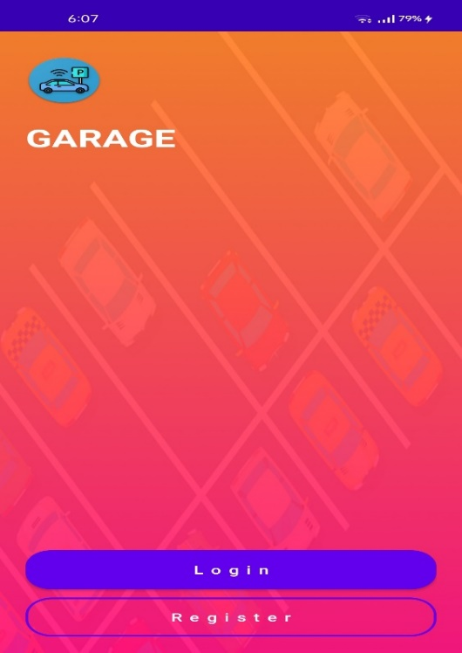

**After registering to the app you should login to save your data:**

**Register page : login page:**

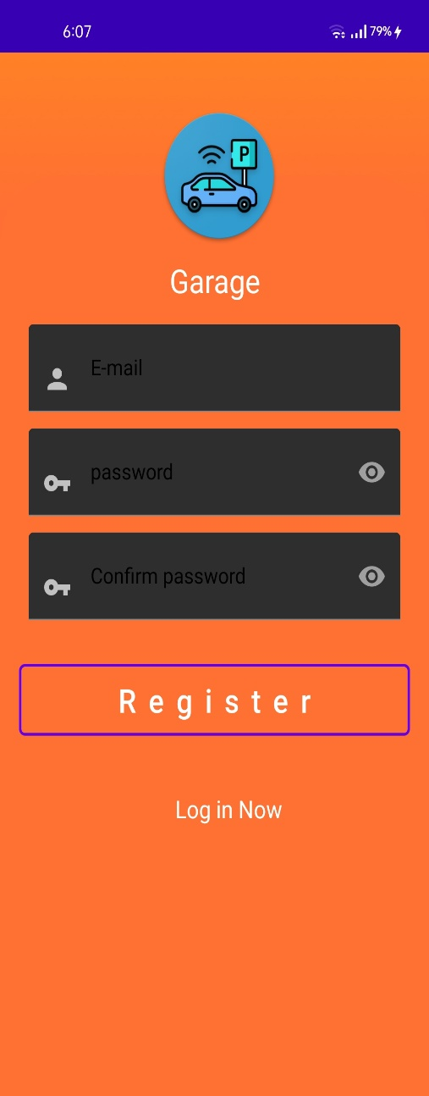 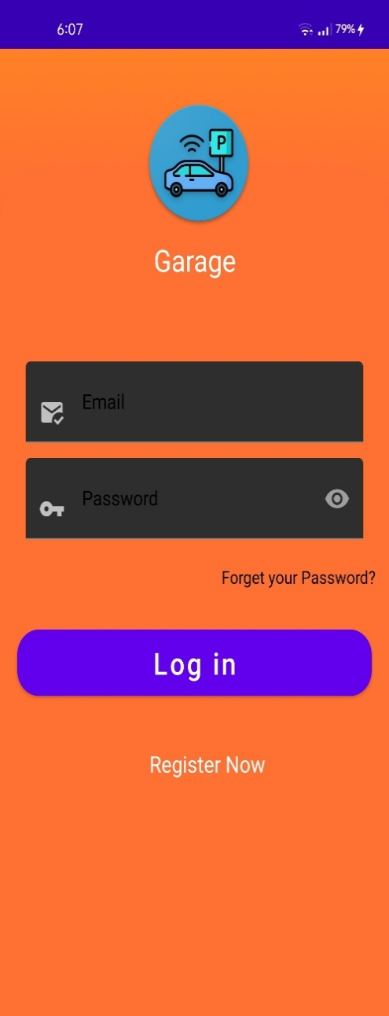

**Here is the home page to use the application select your options:**

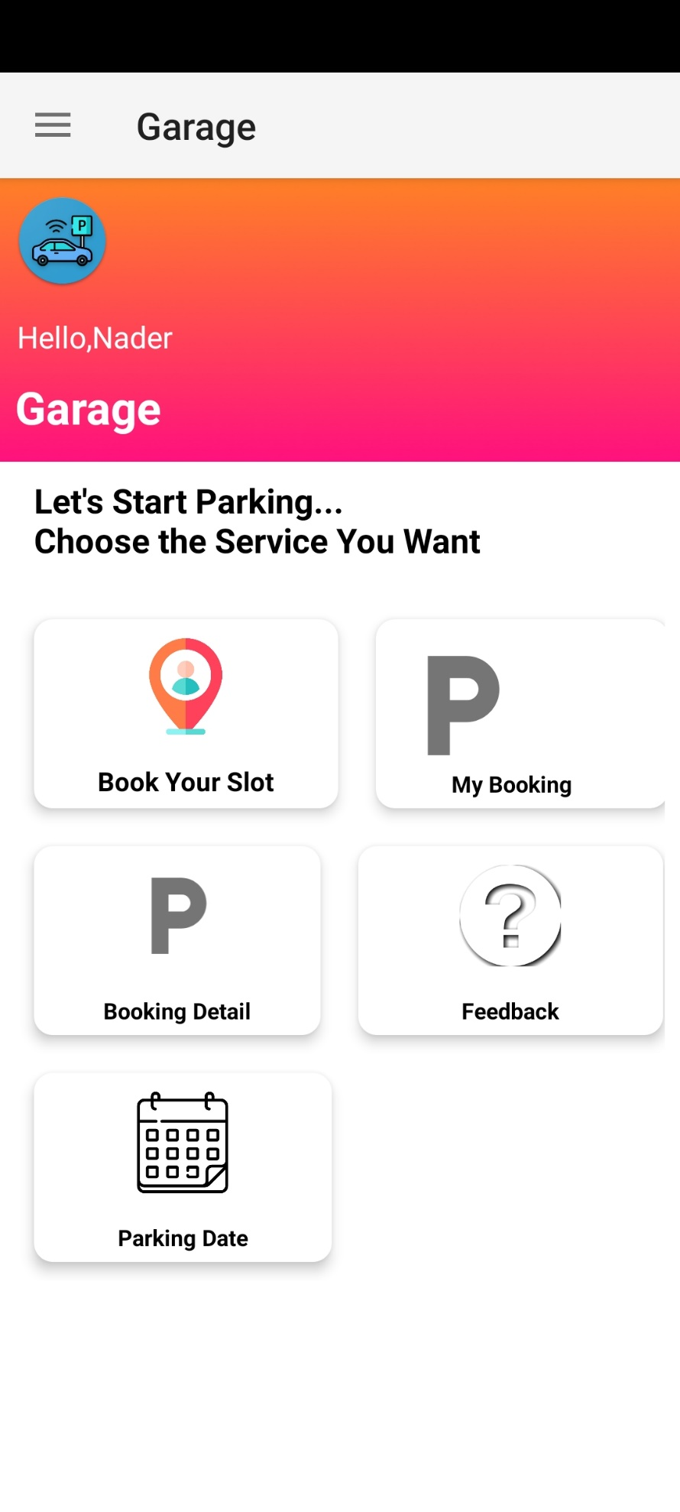

**Menu drawer is to know :**

* more about us
* choose your distenation to park spot
* share your experience to your friends.
* Logout from your account

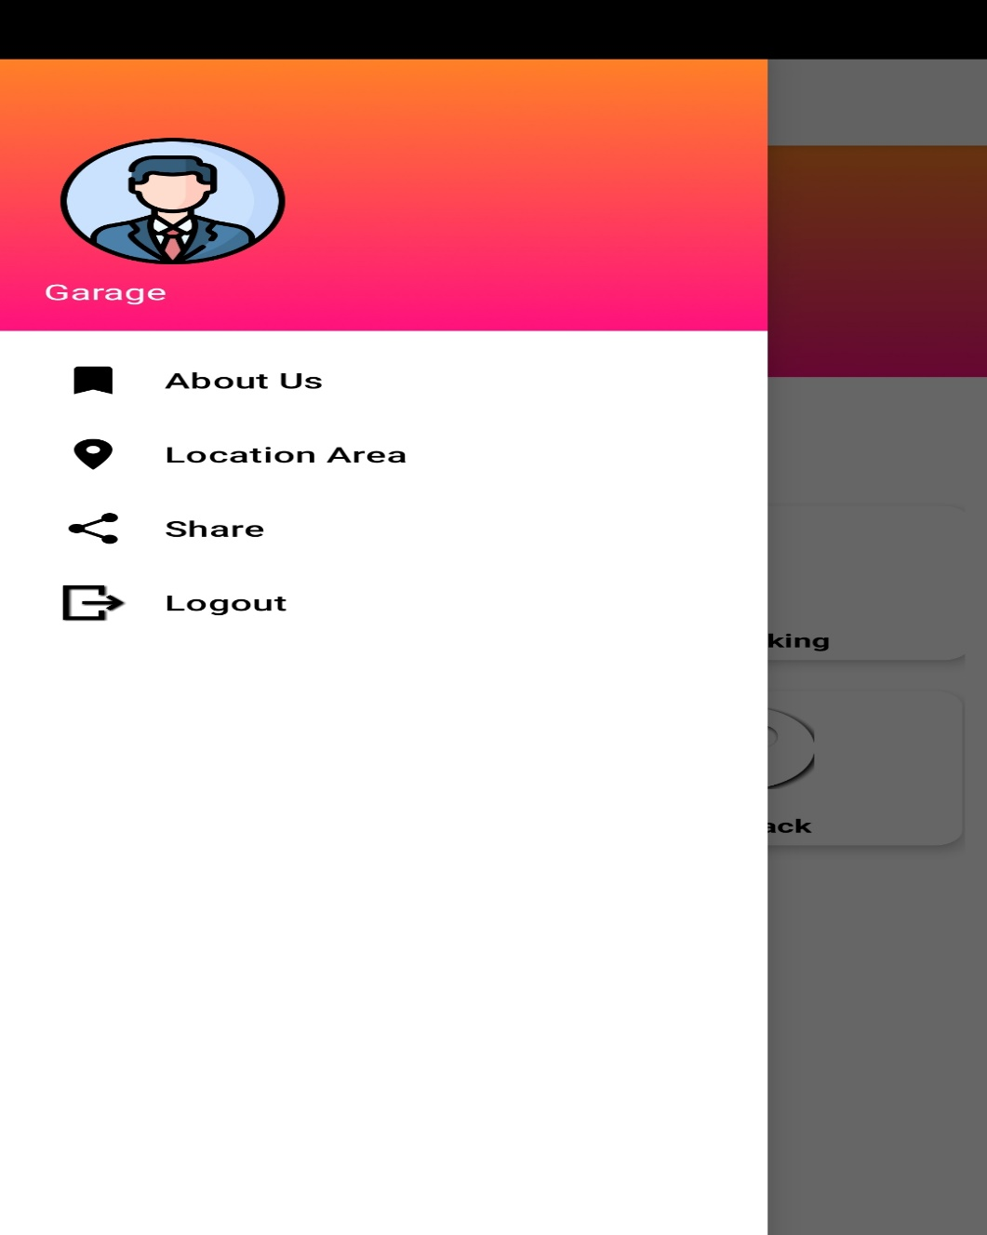

**Parking spot location to be easy to find your destination:**

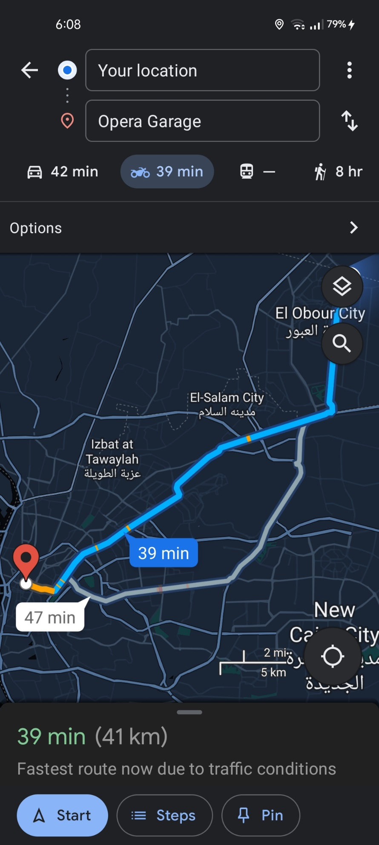

**Select a spot that you want to park in:**

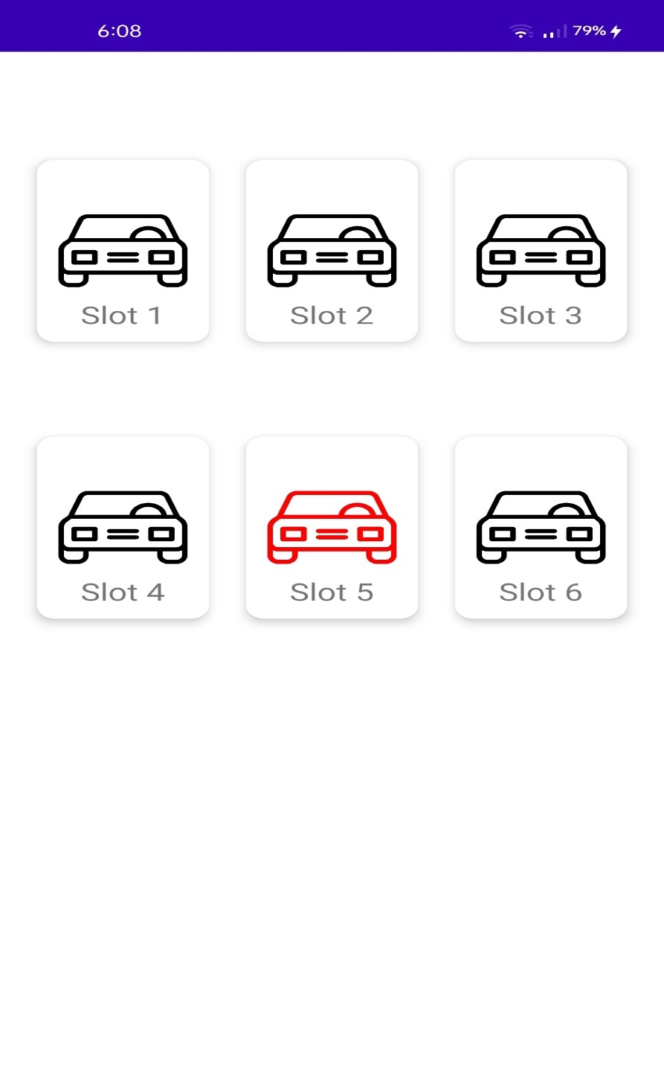

**Pooking fees:**

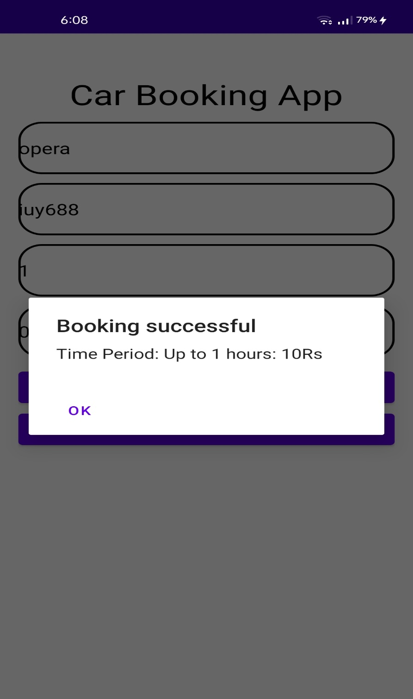

**Booking details to know more info about your experience :**

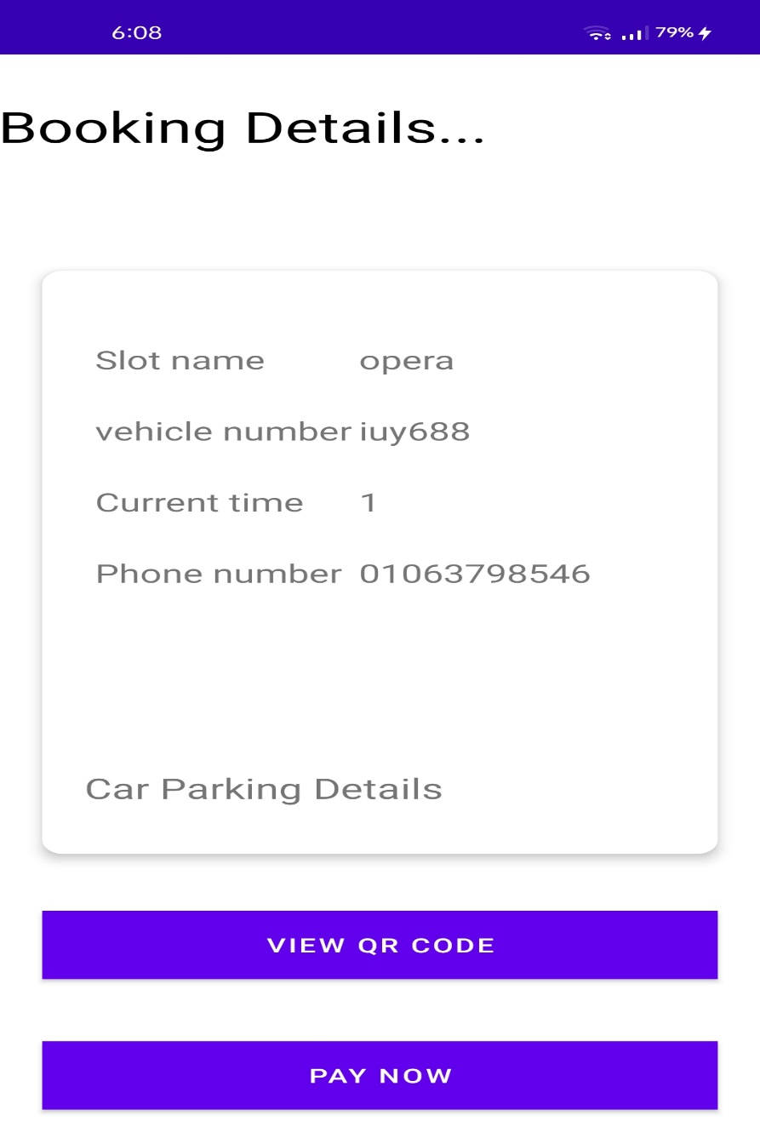

**Payment page to pay and check in :**

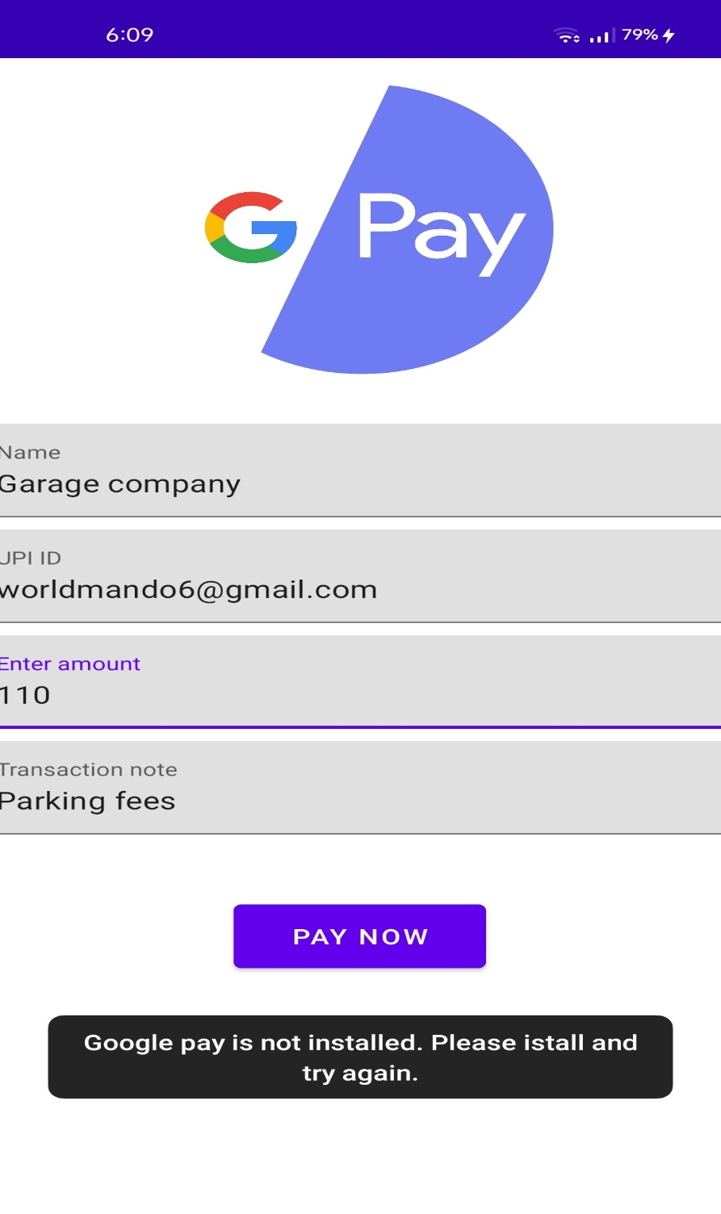

**Qr-code for secure to do not let any one use your account :**

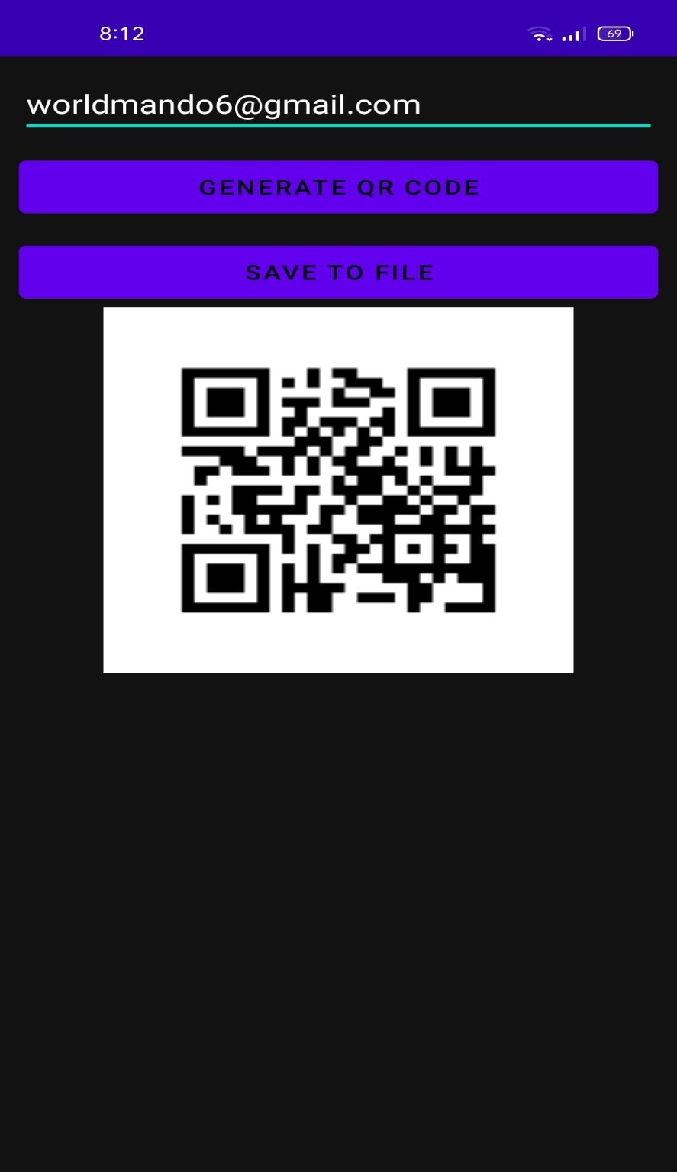

**Share your Experiment with friends:**

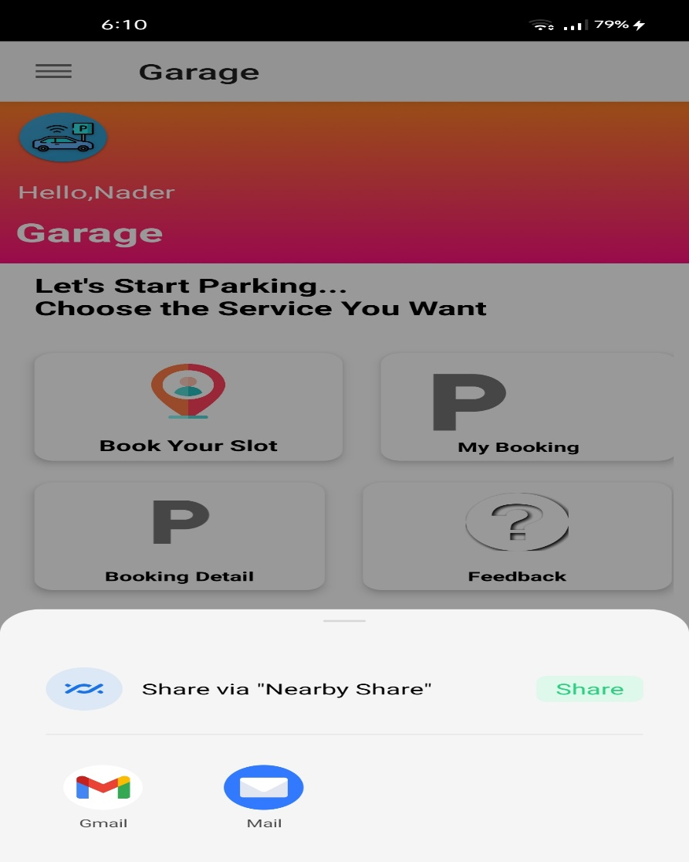

**Date** :

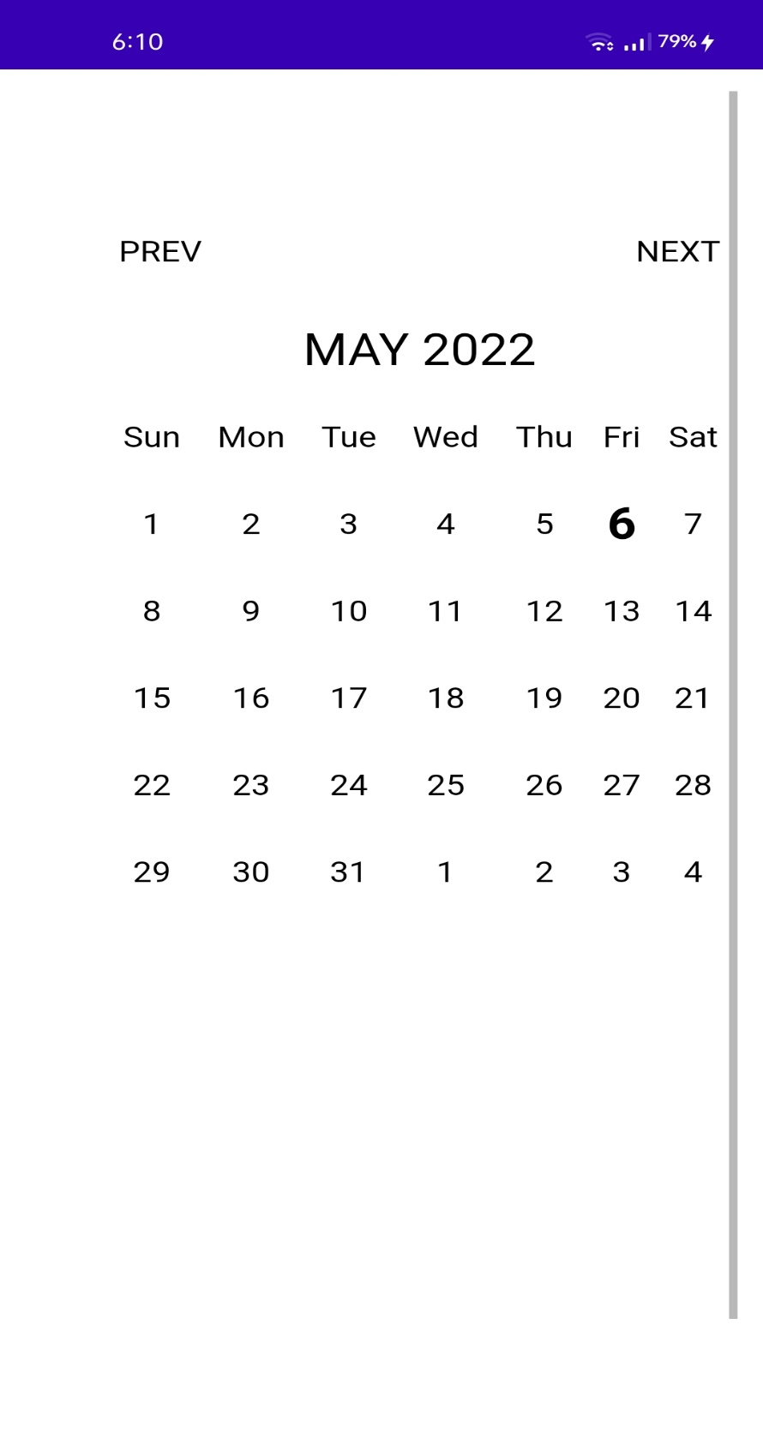

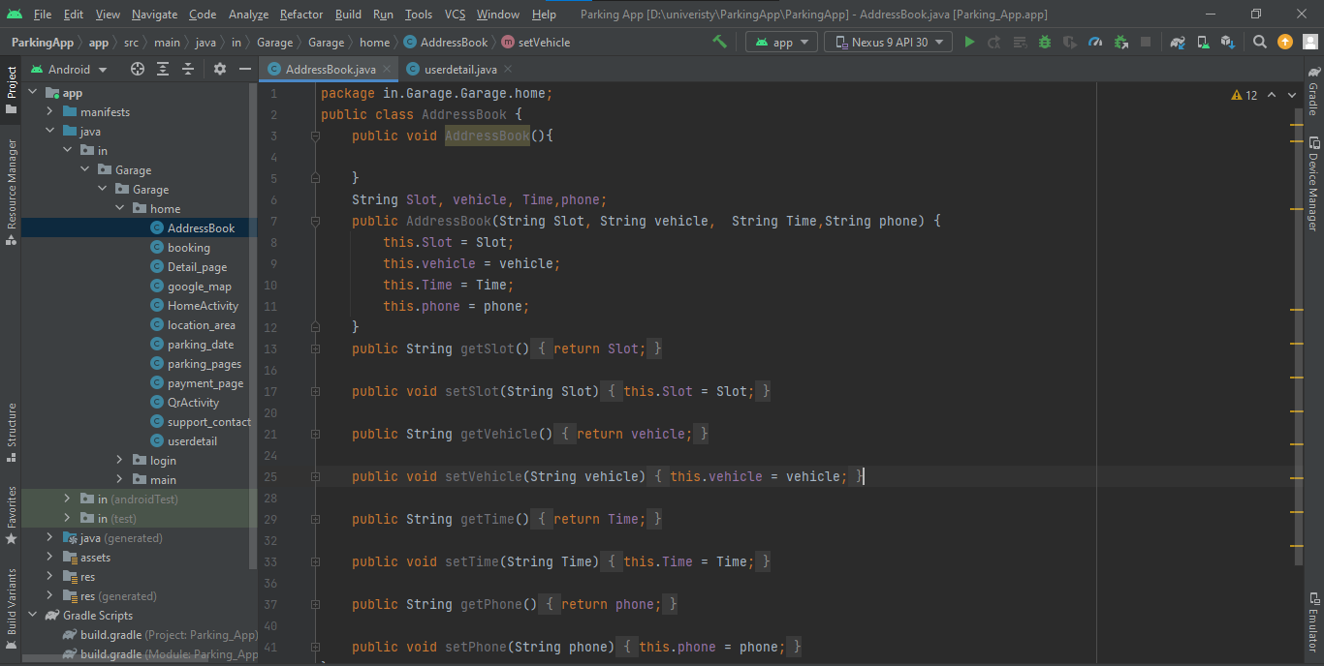

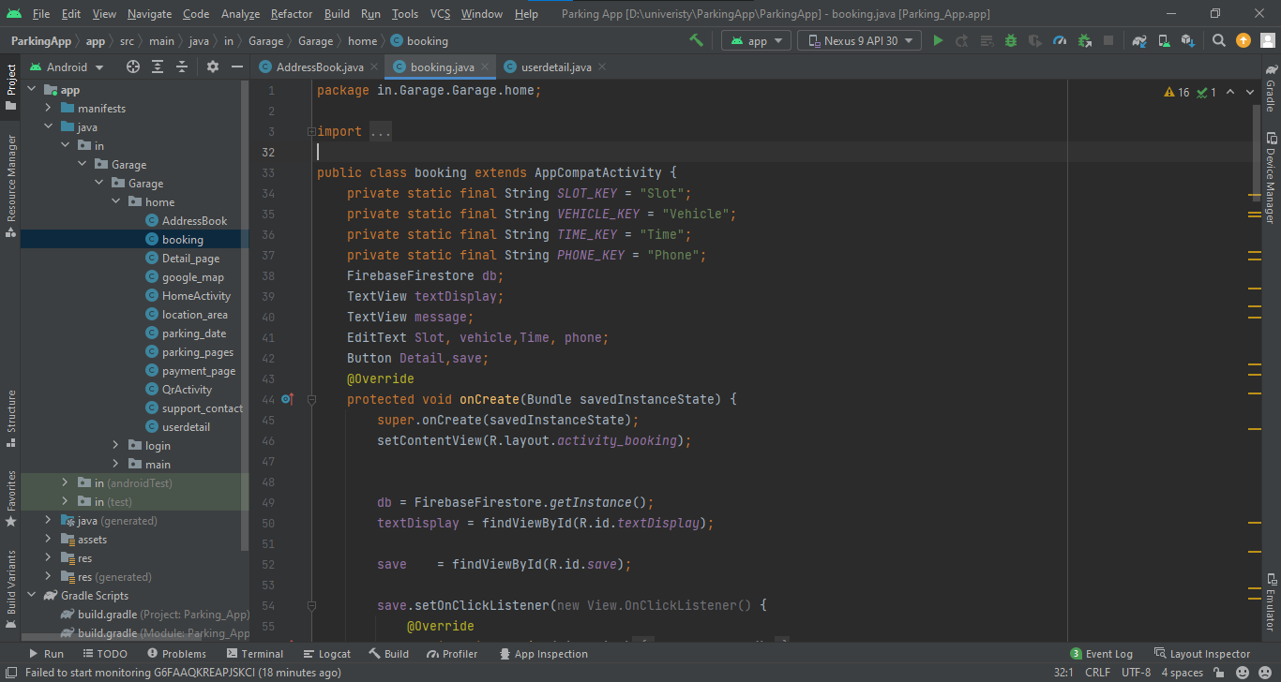

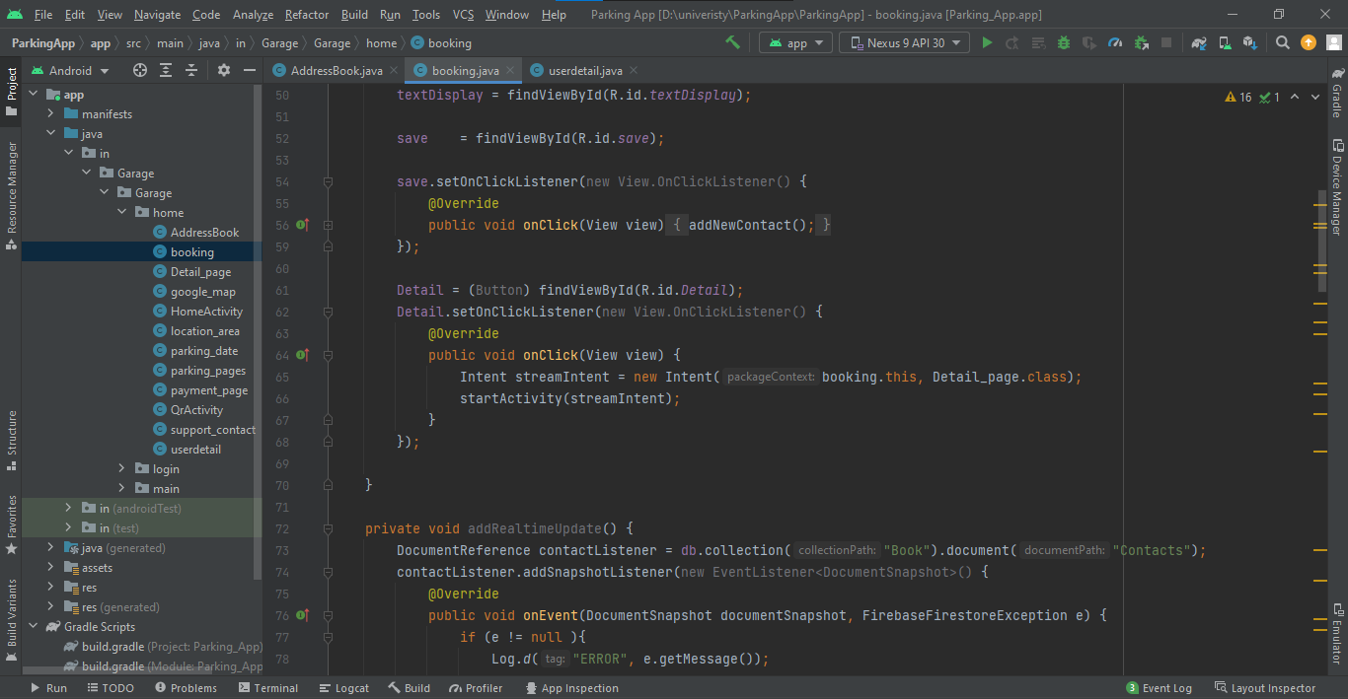

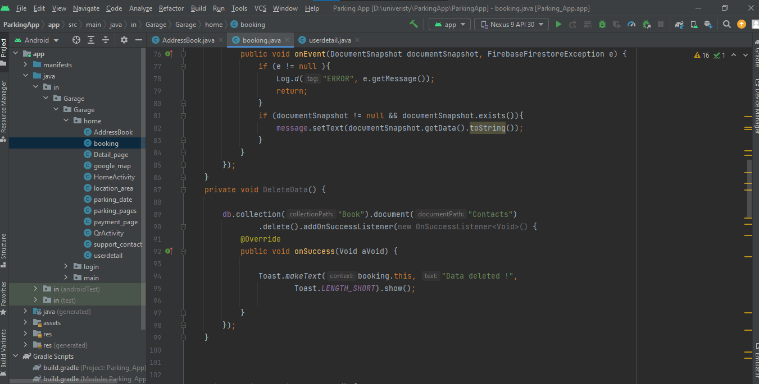

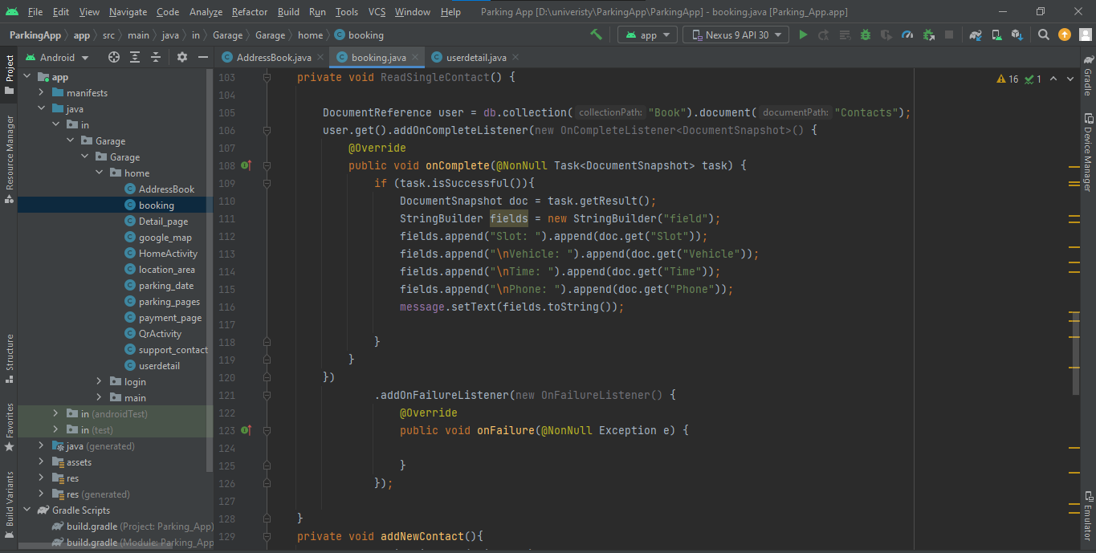

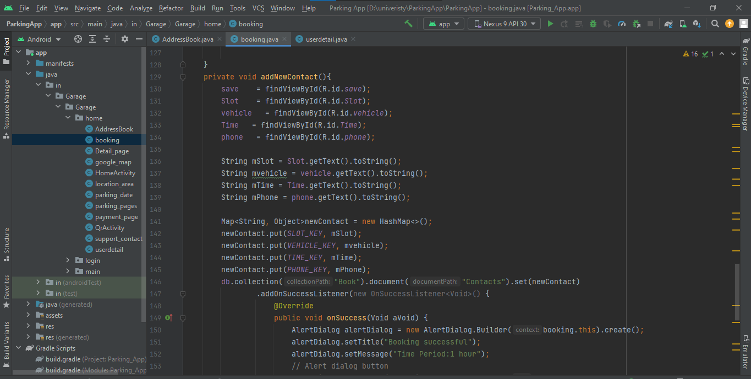

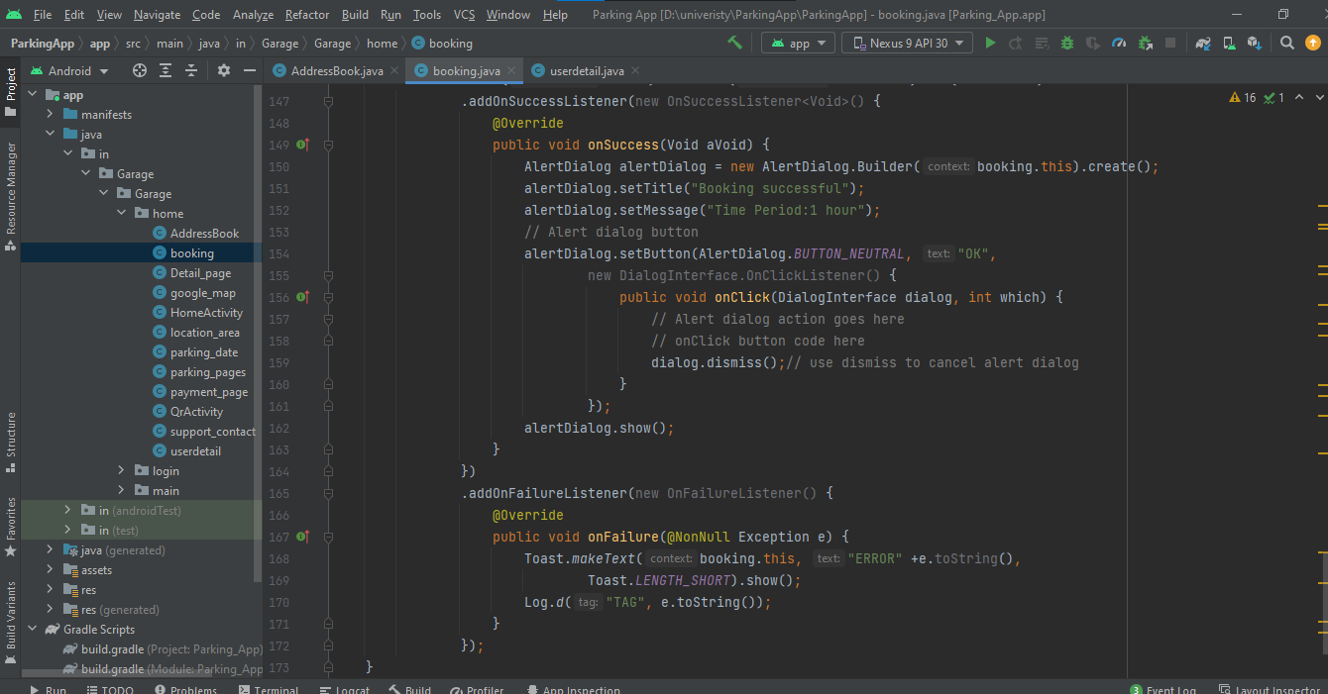

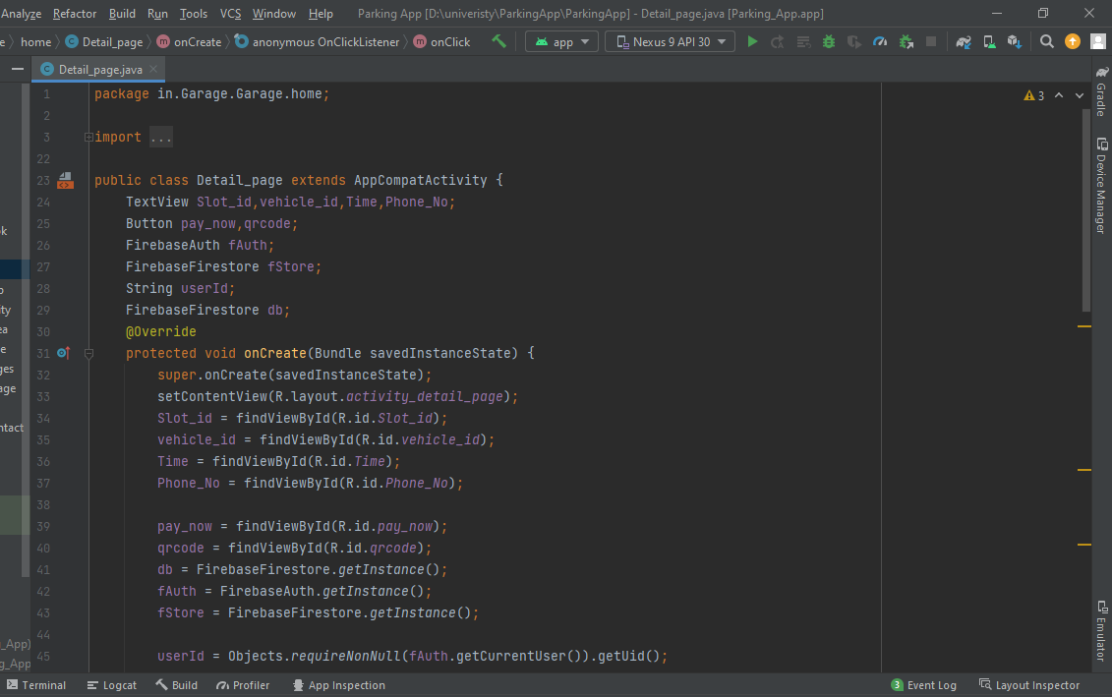

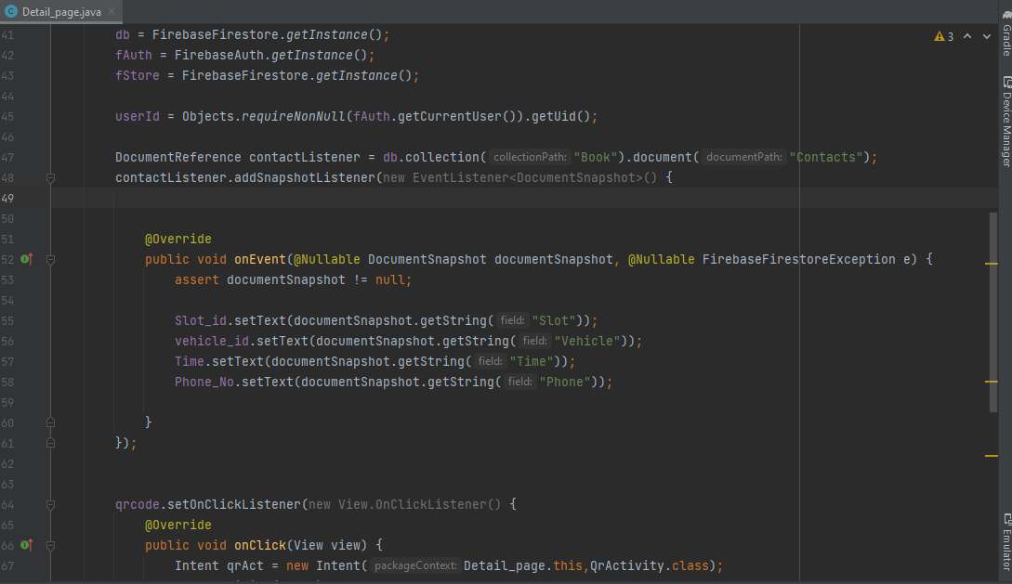

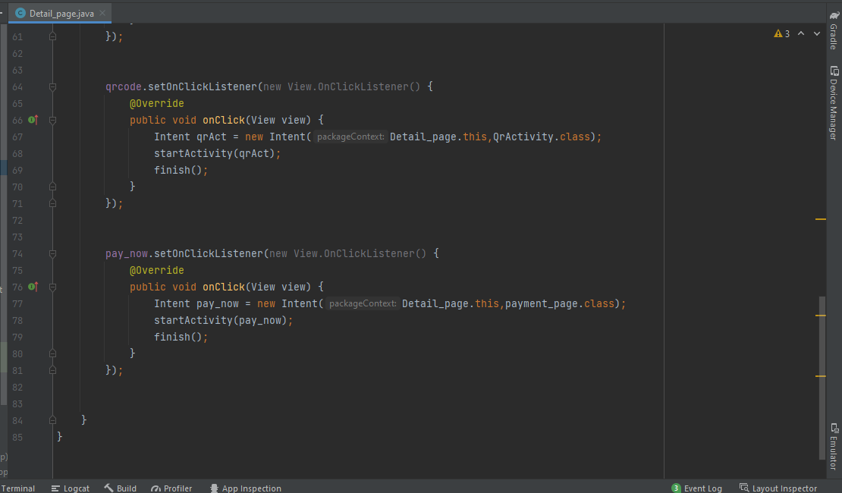

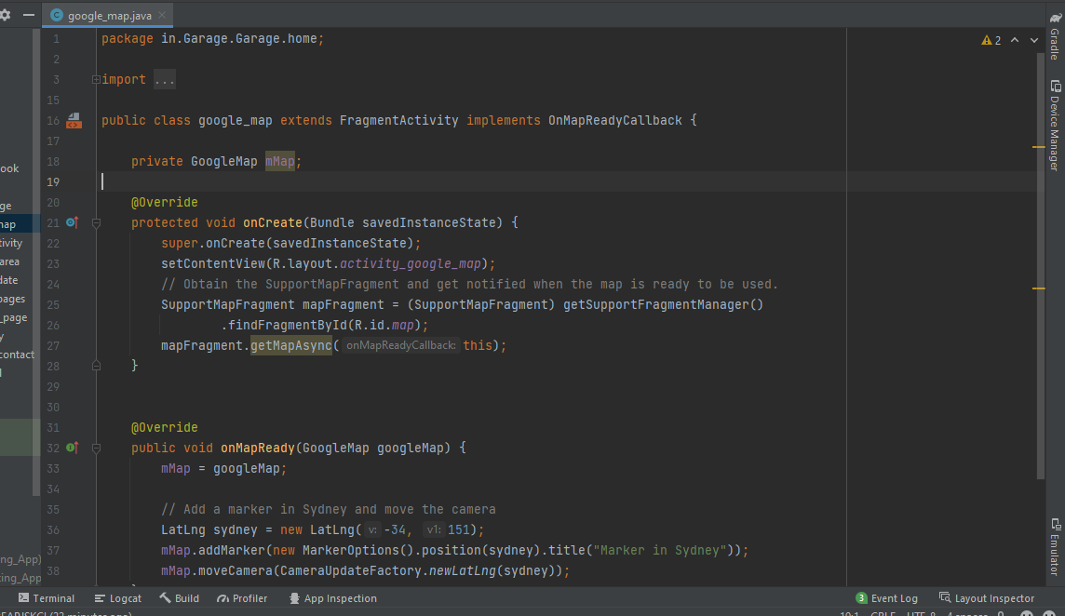

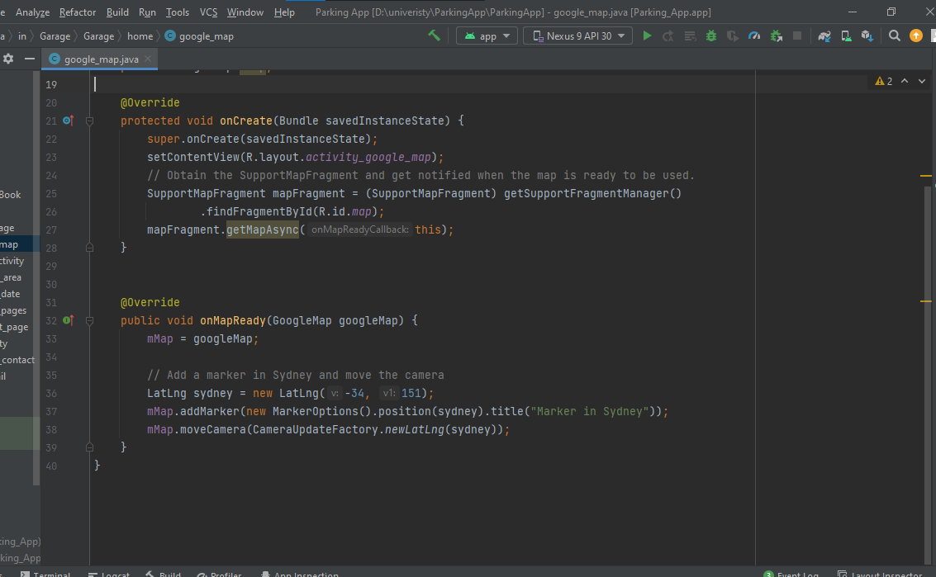

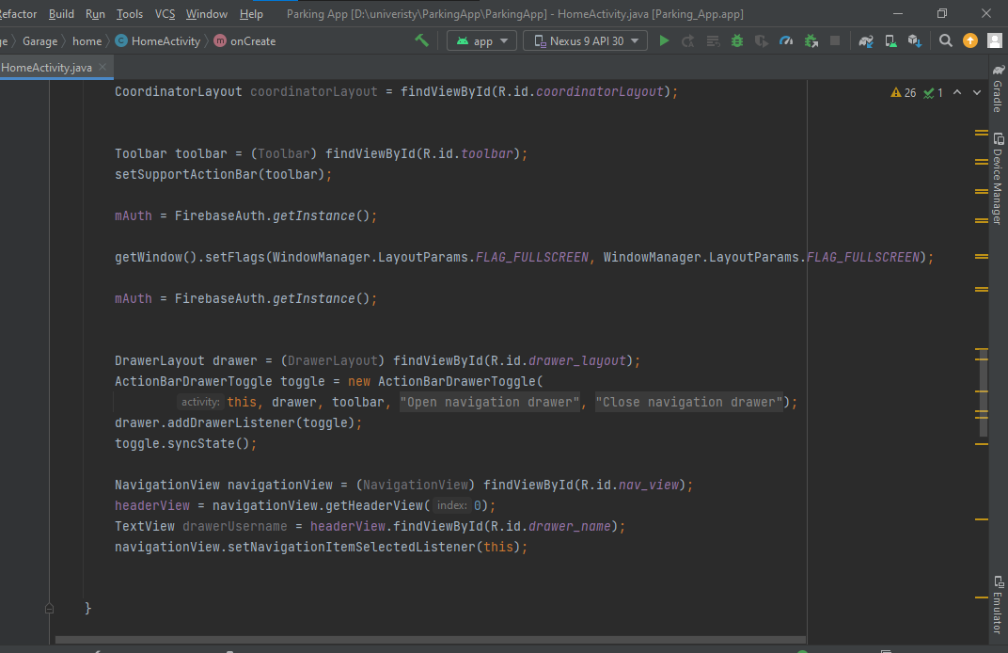

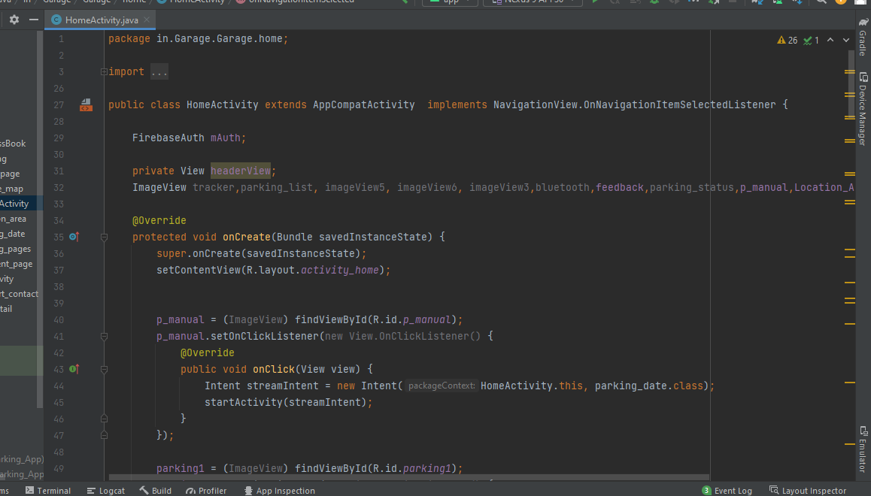

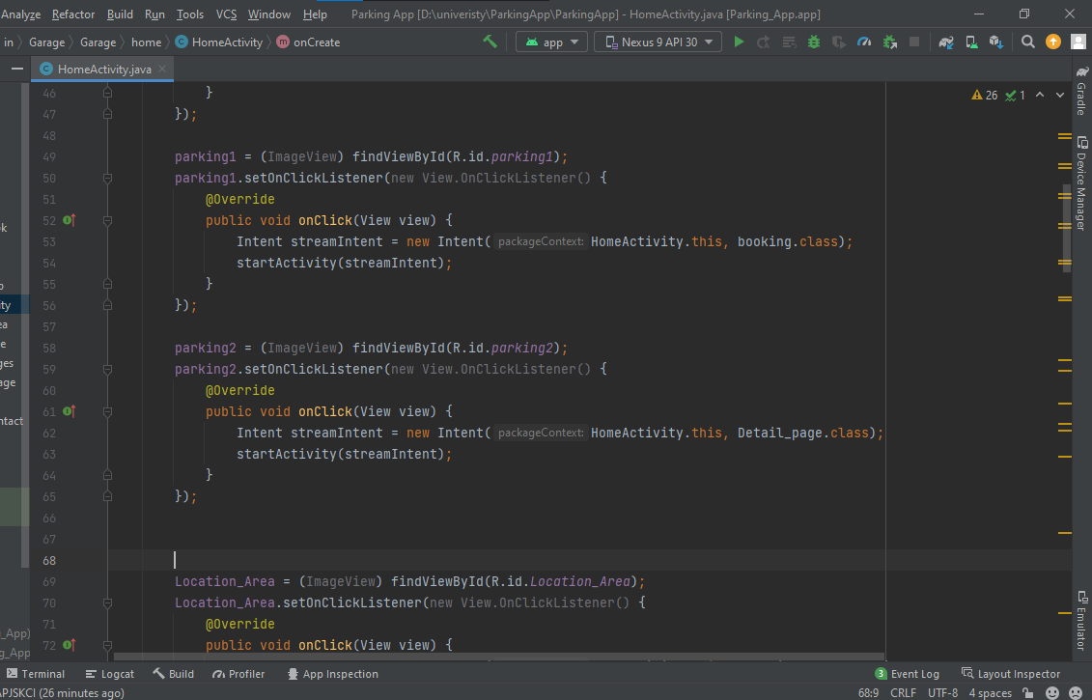

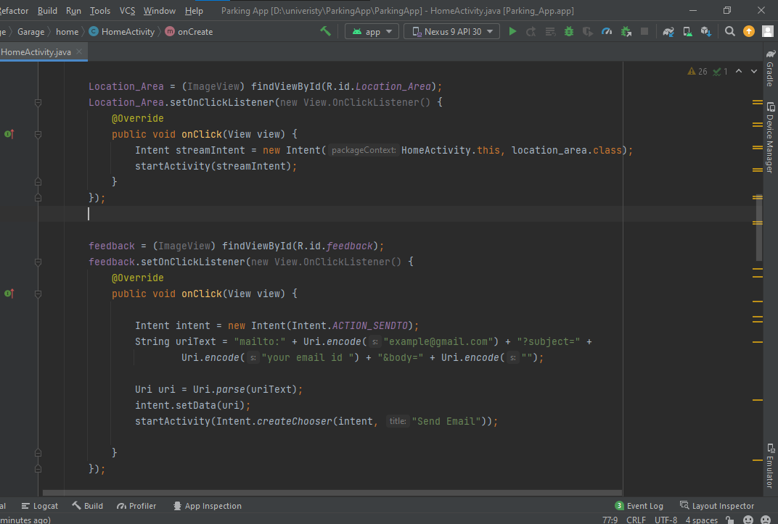

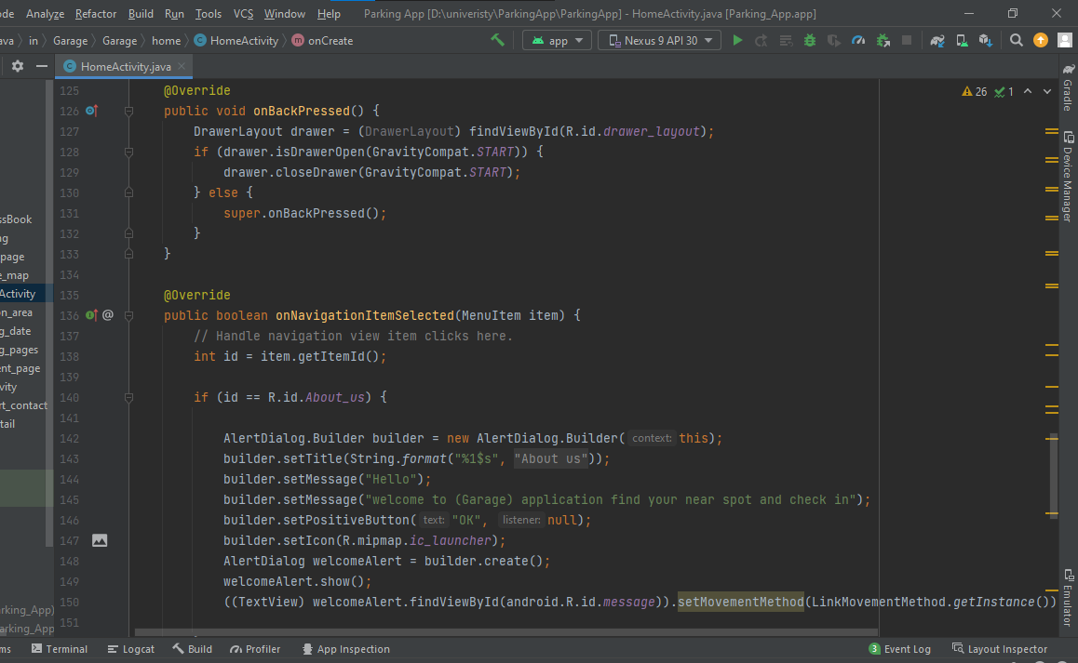

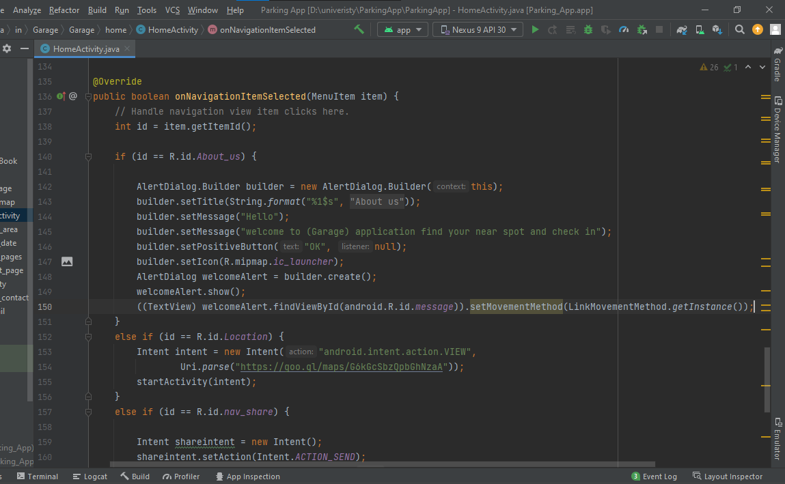

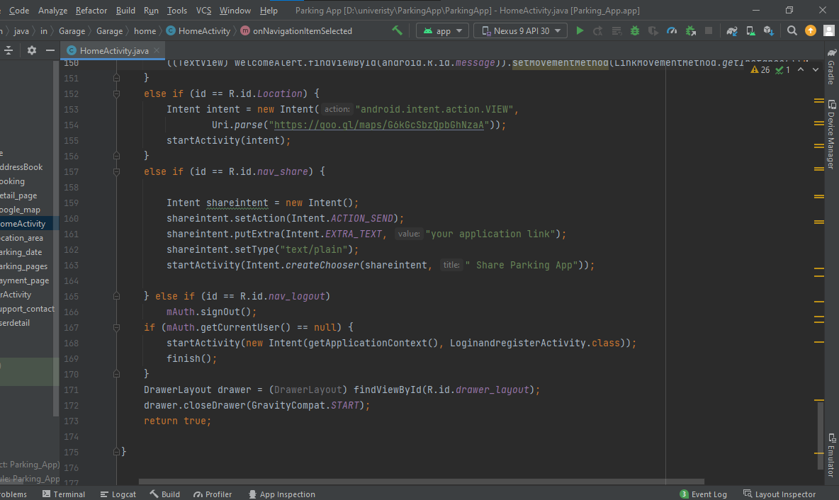

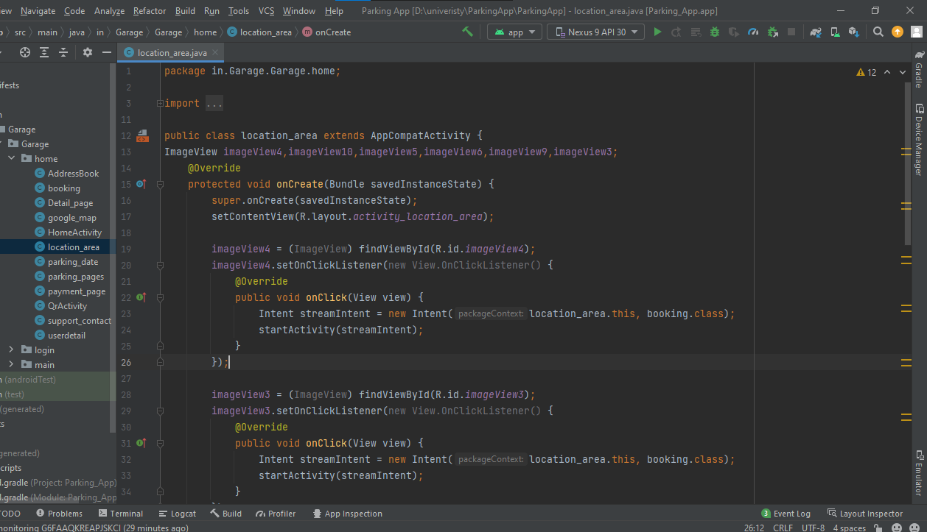

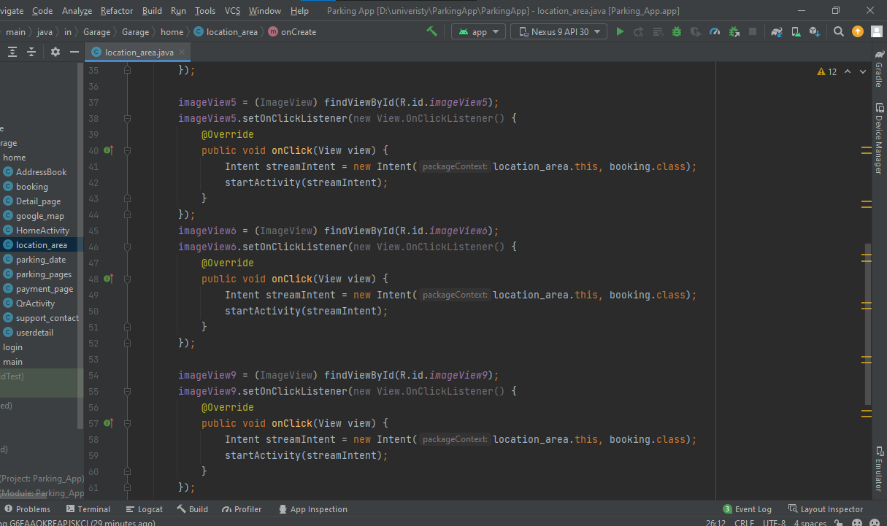

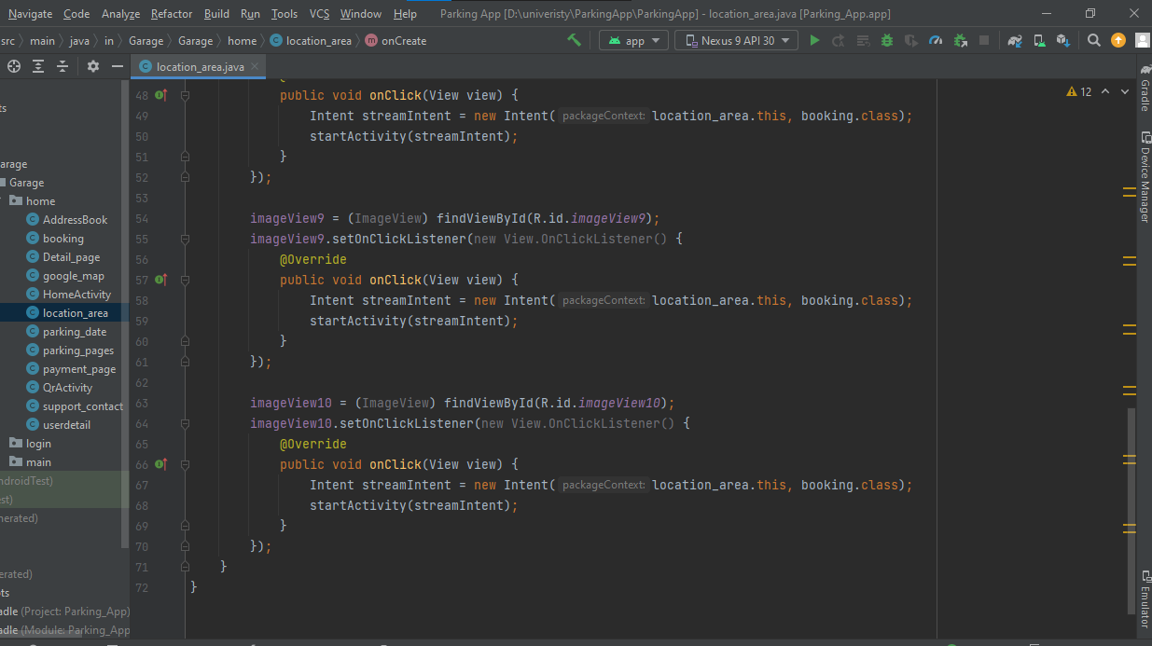

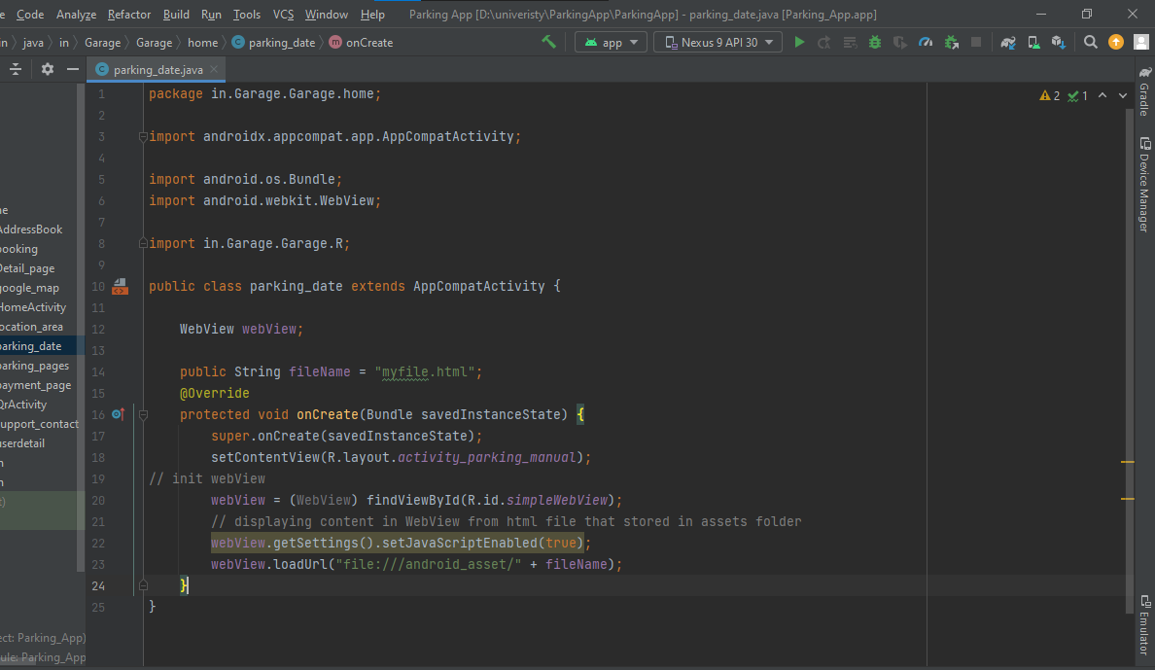

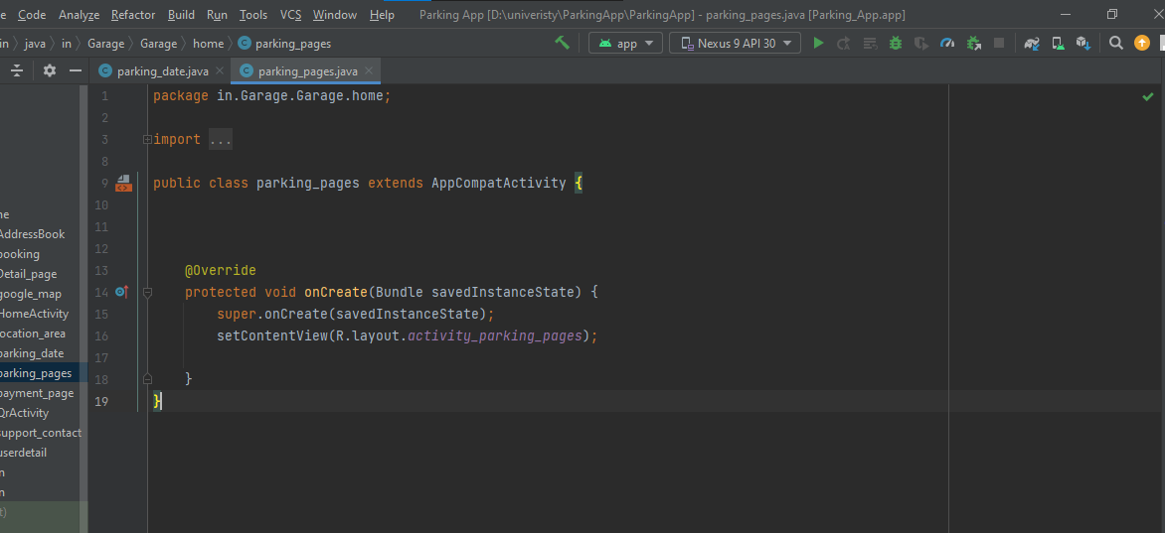

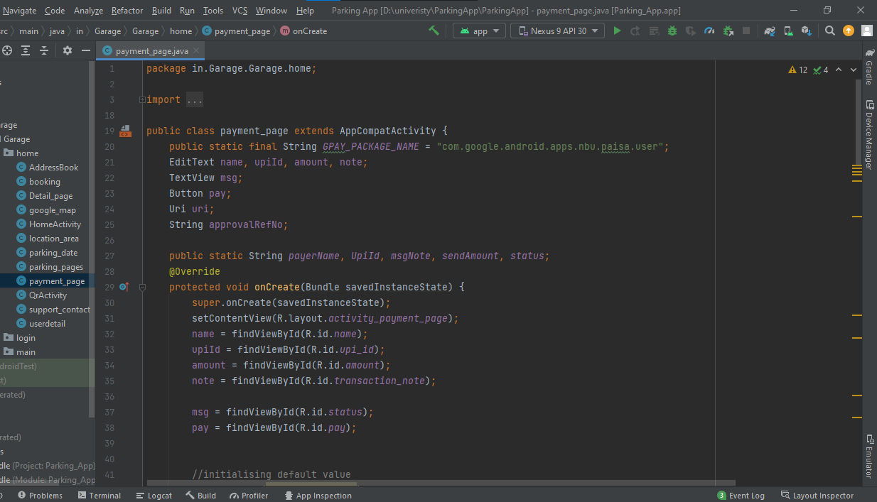

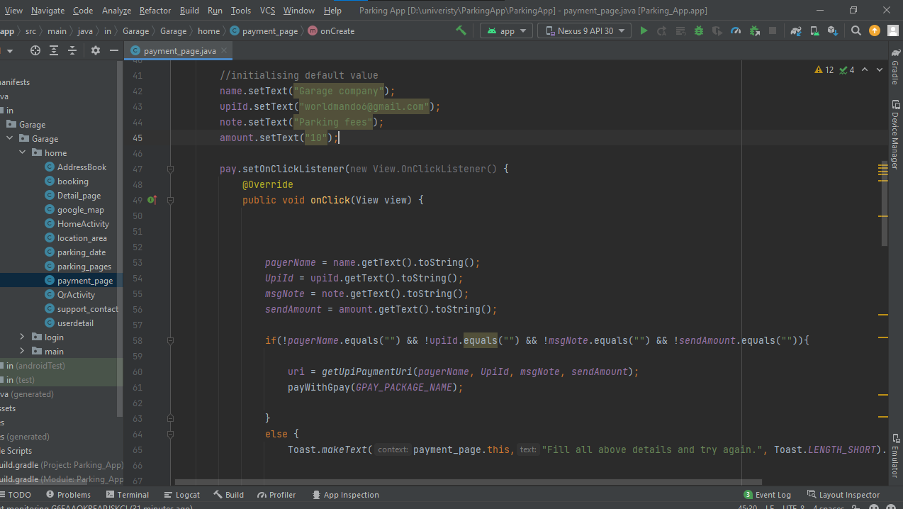

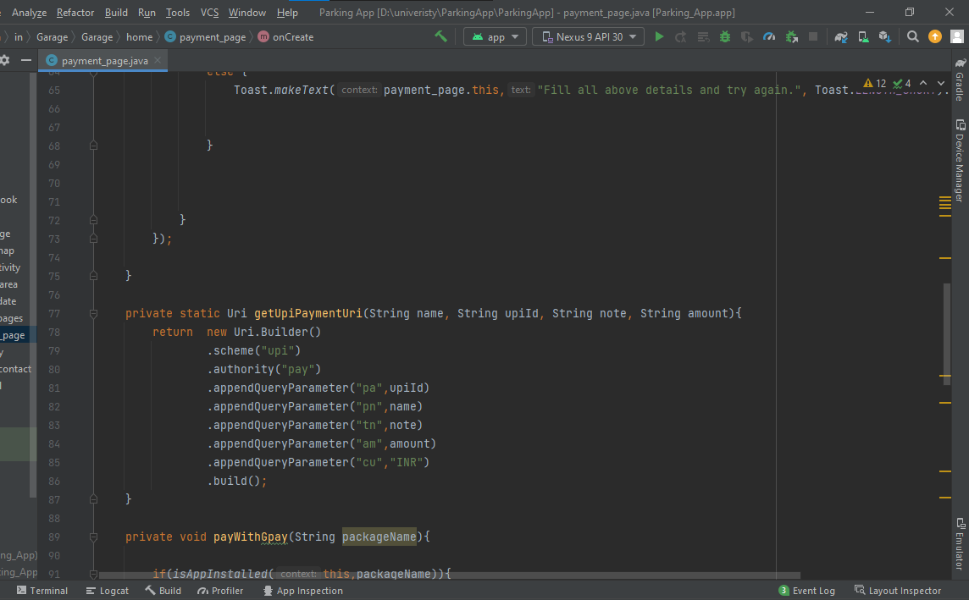

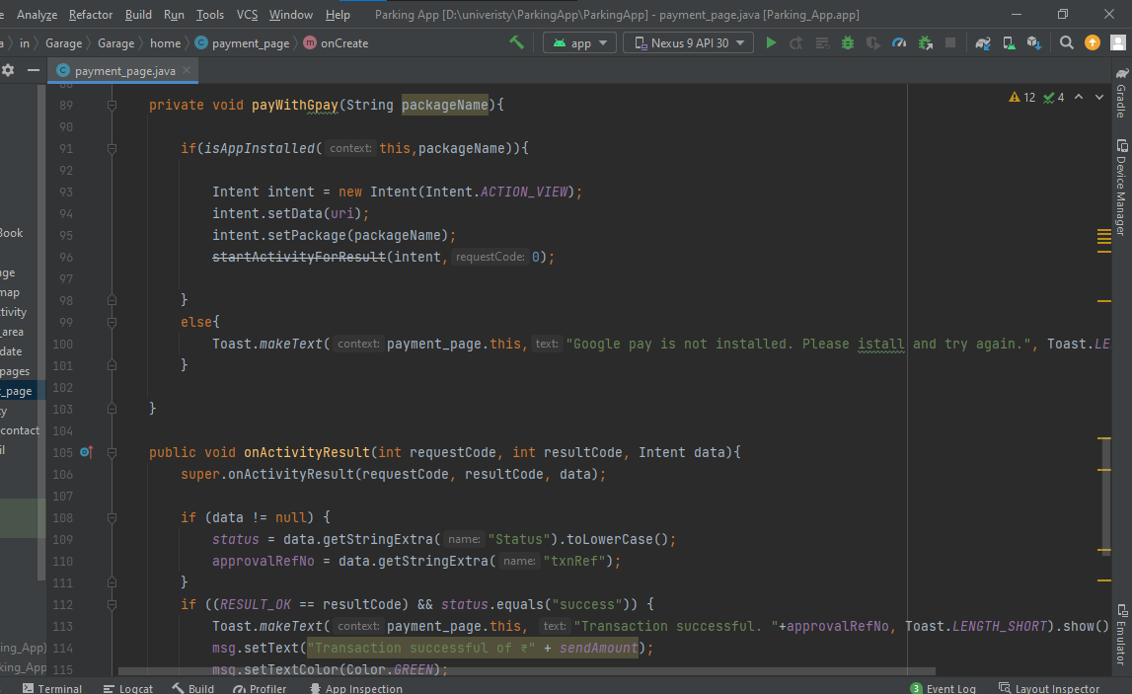

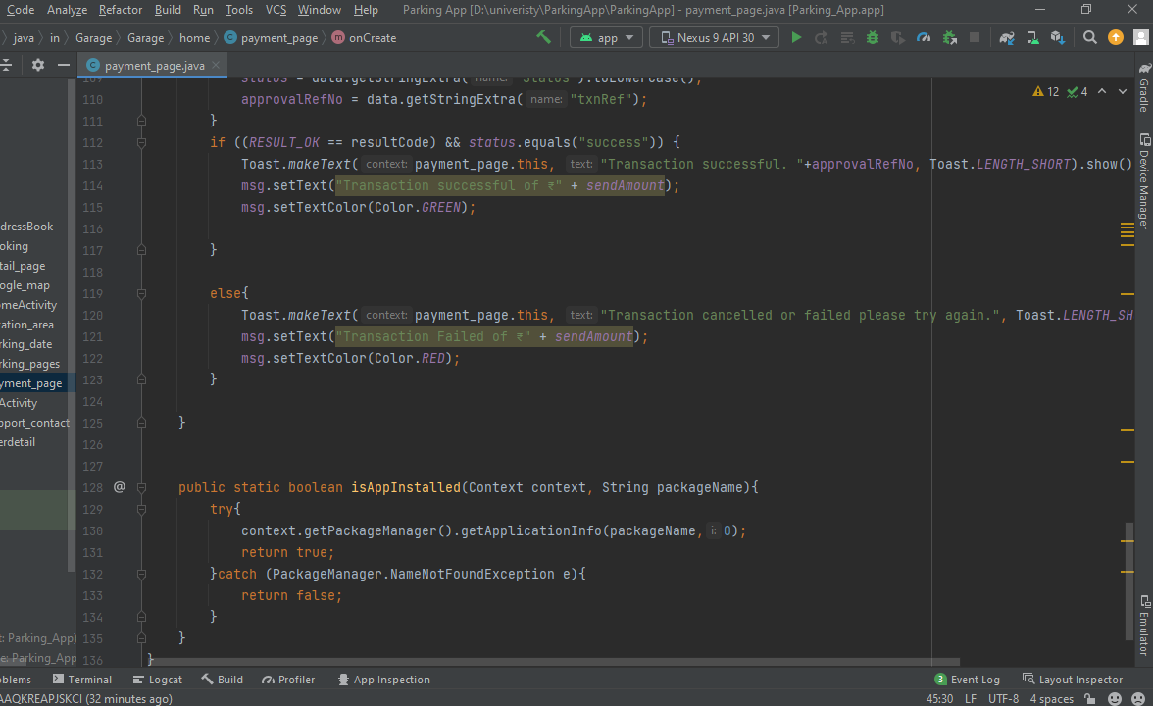

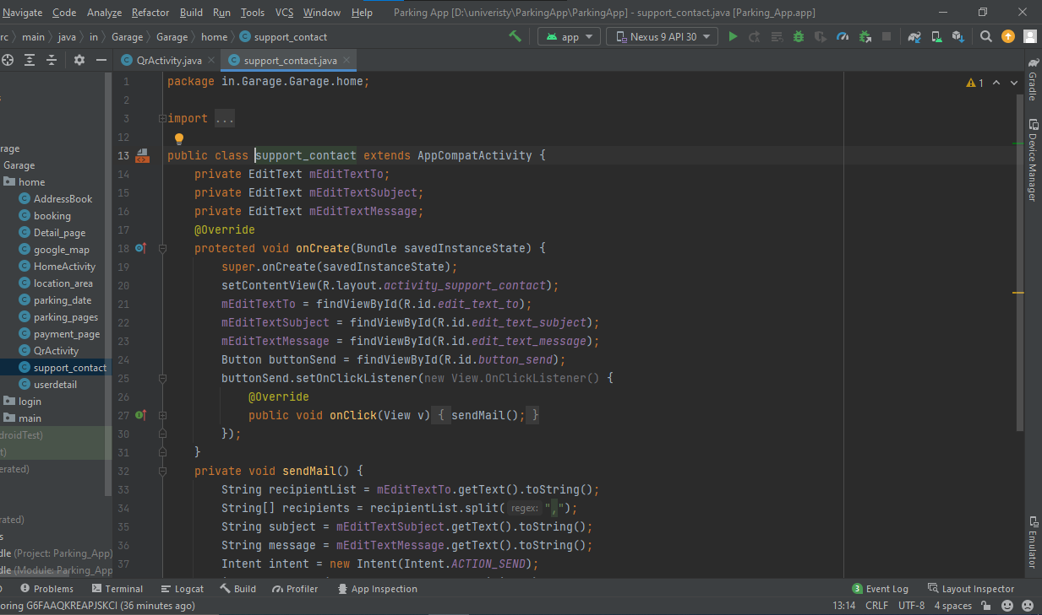

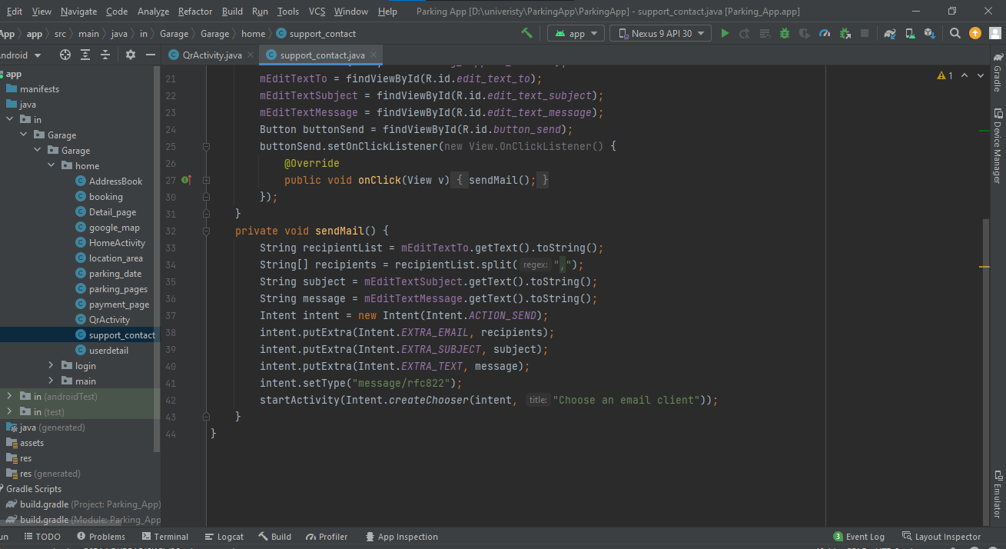

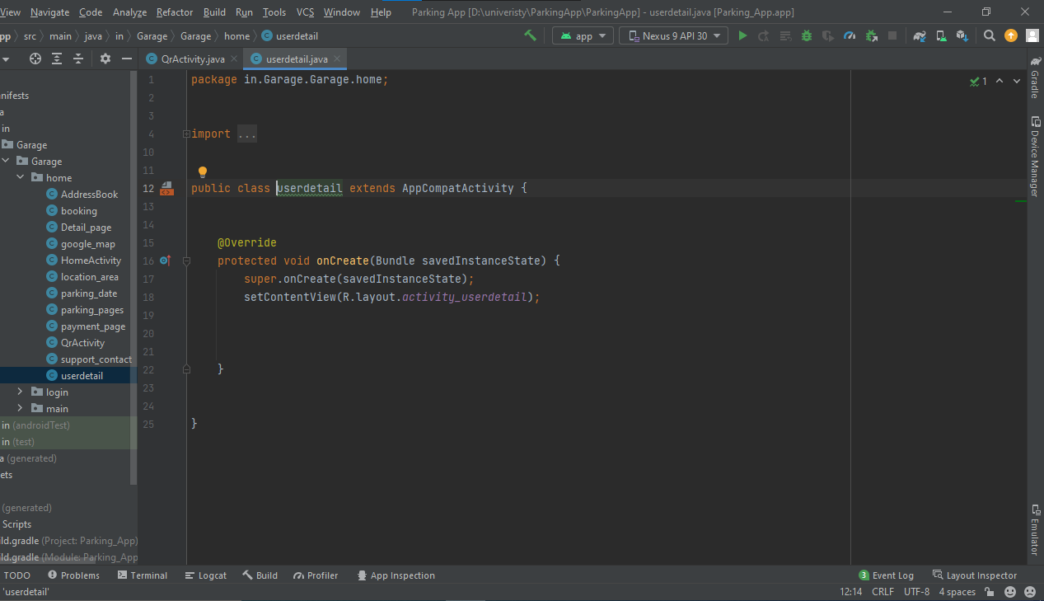

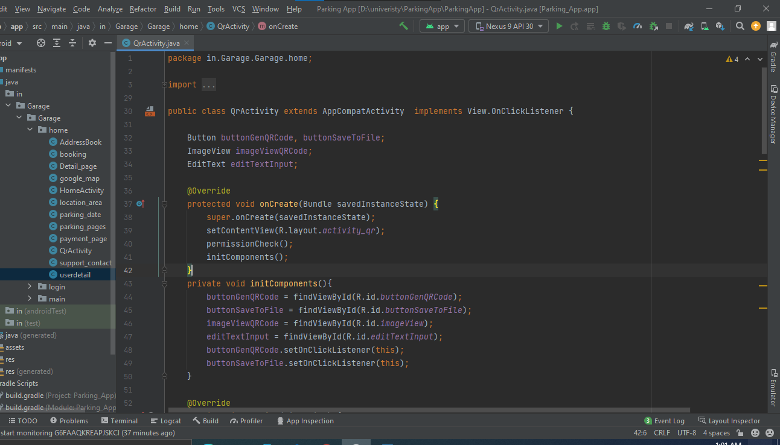

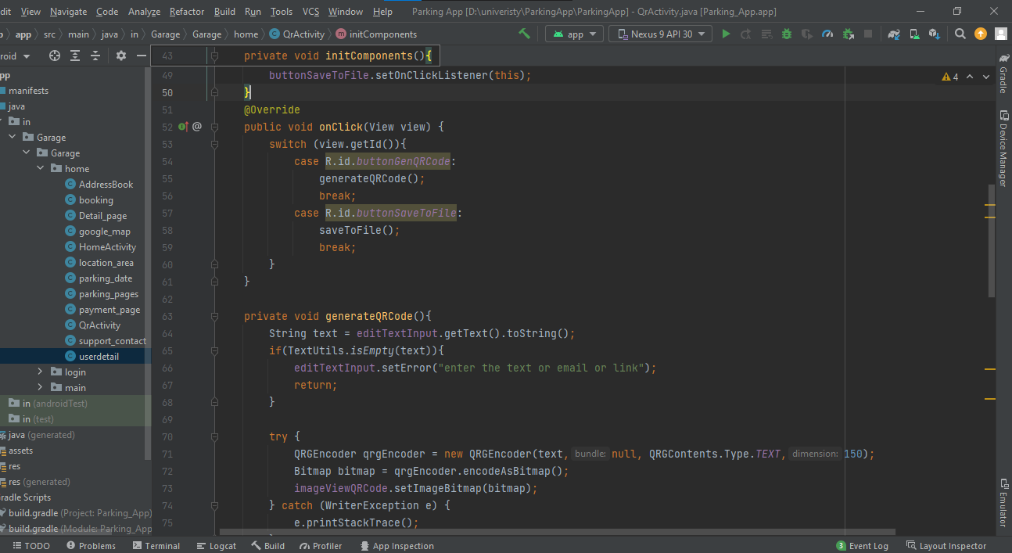

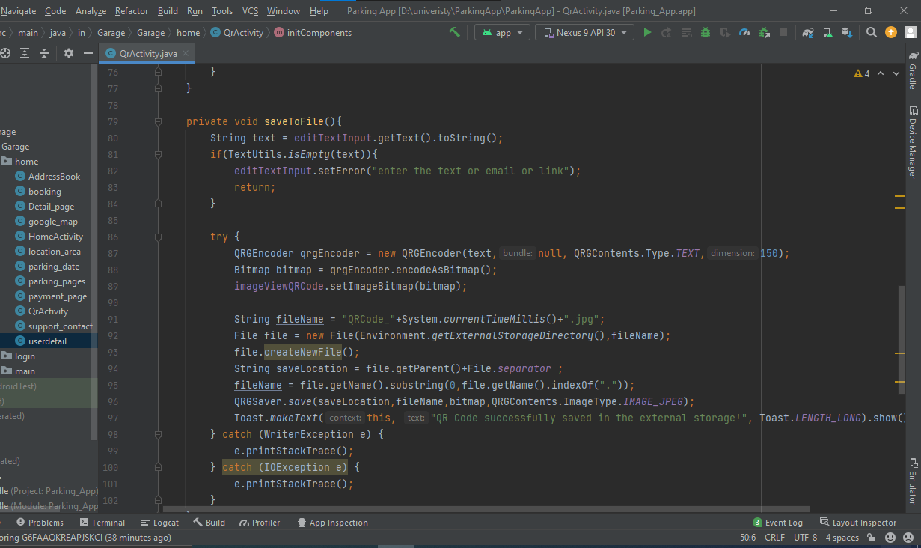

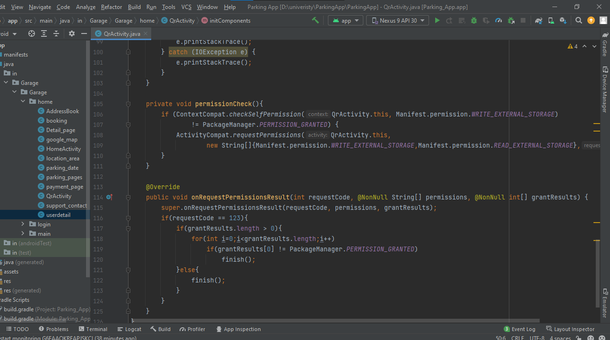

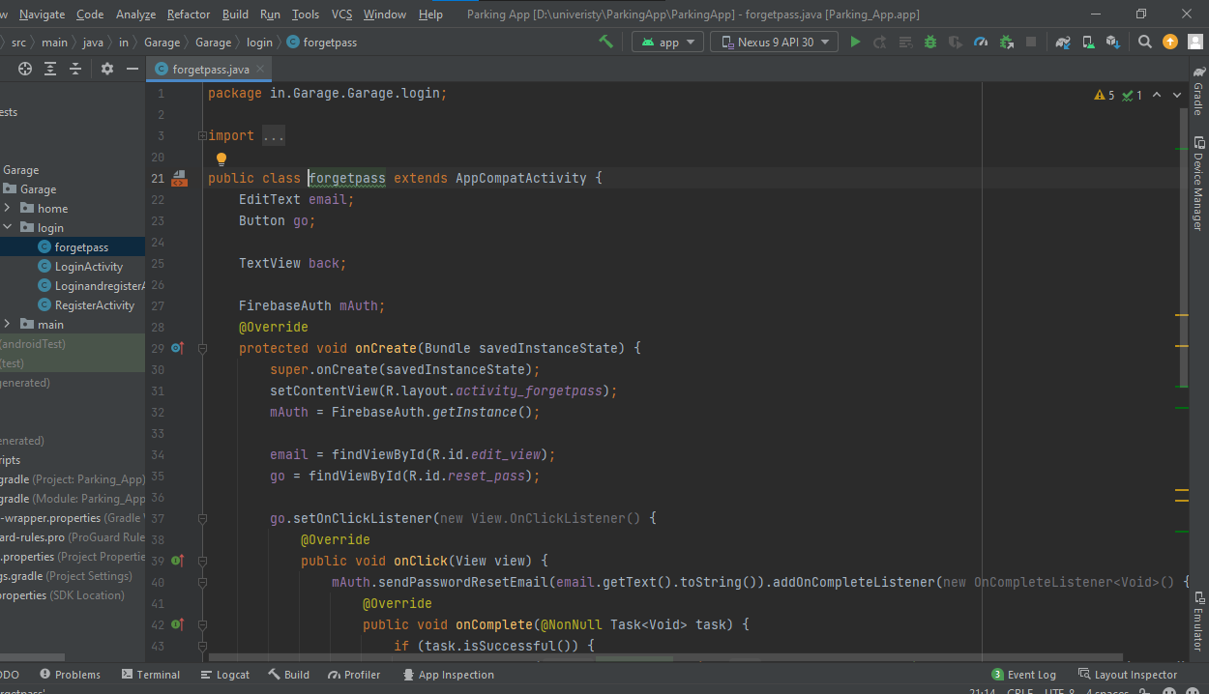

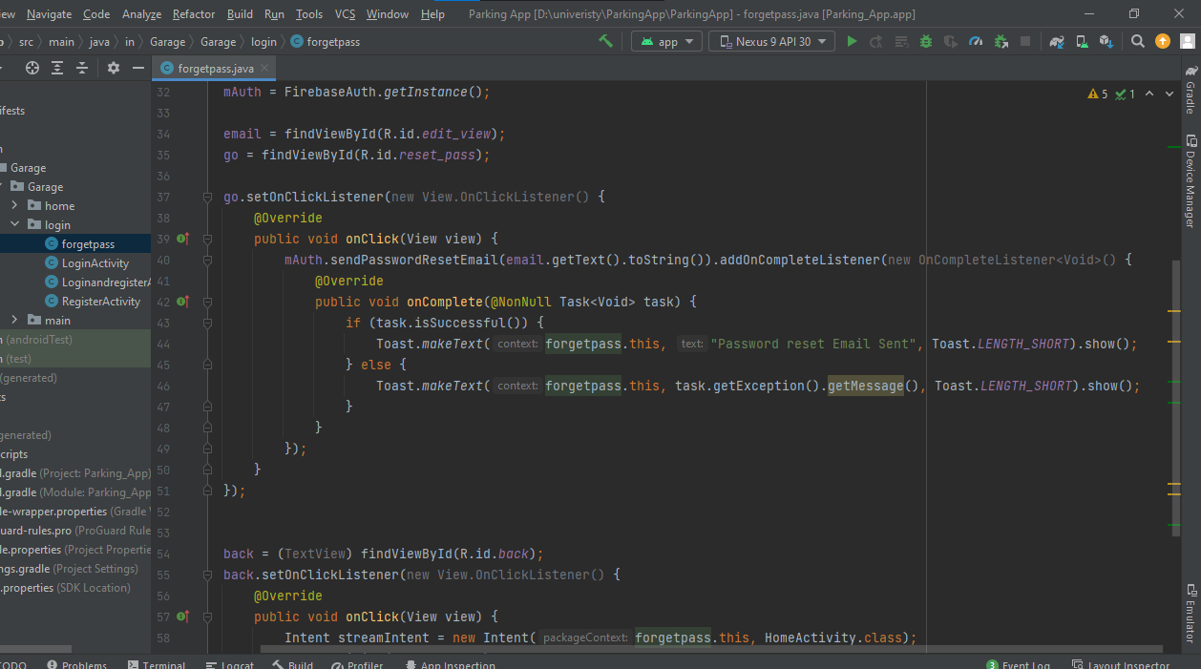

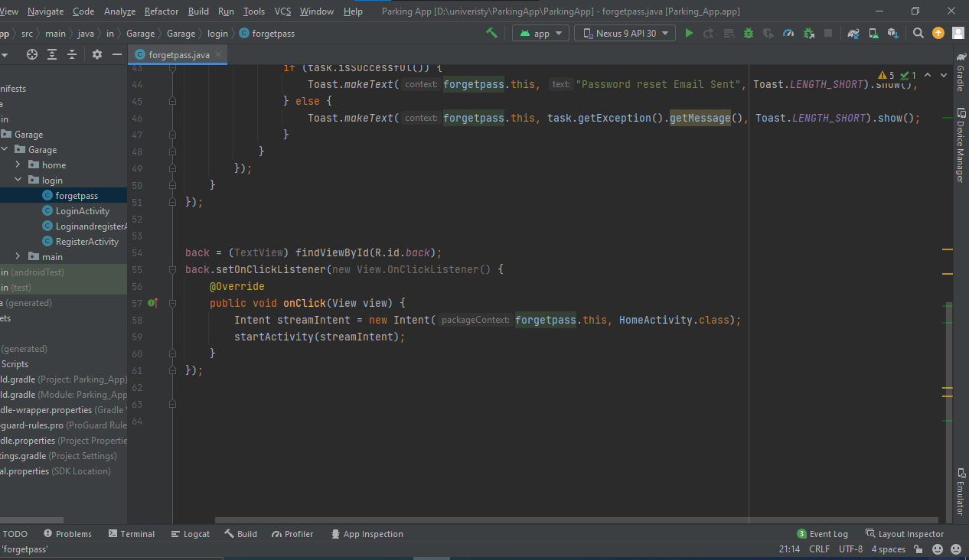

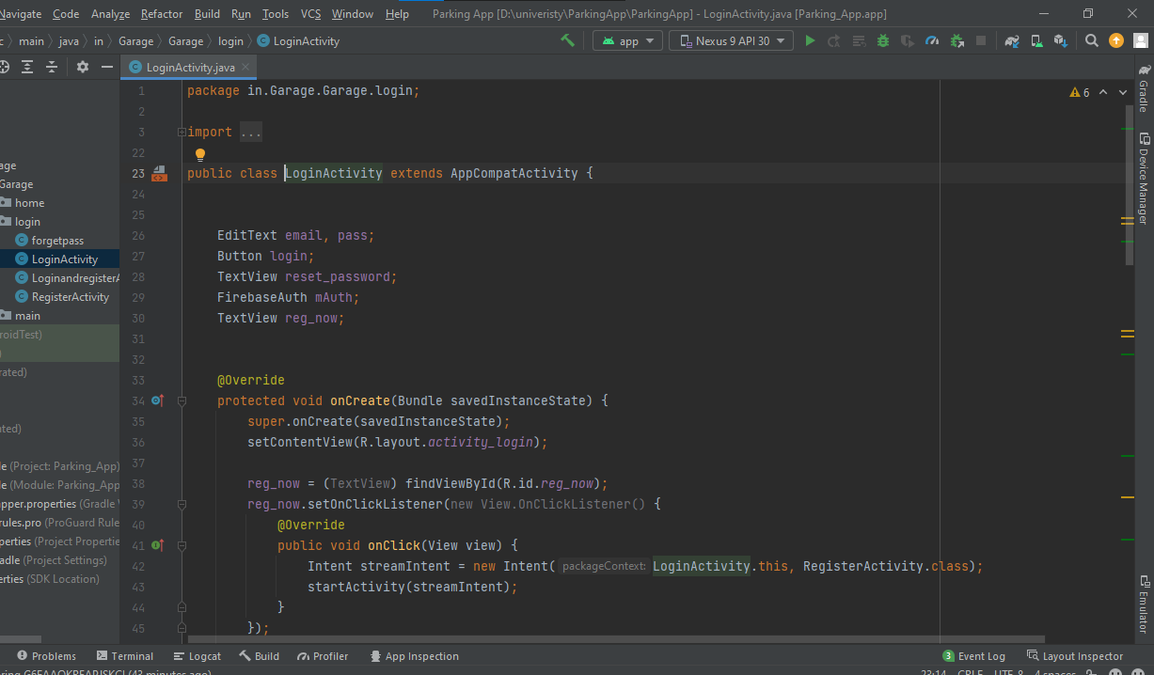

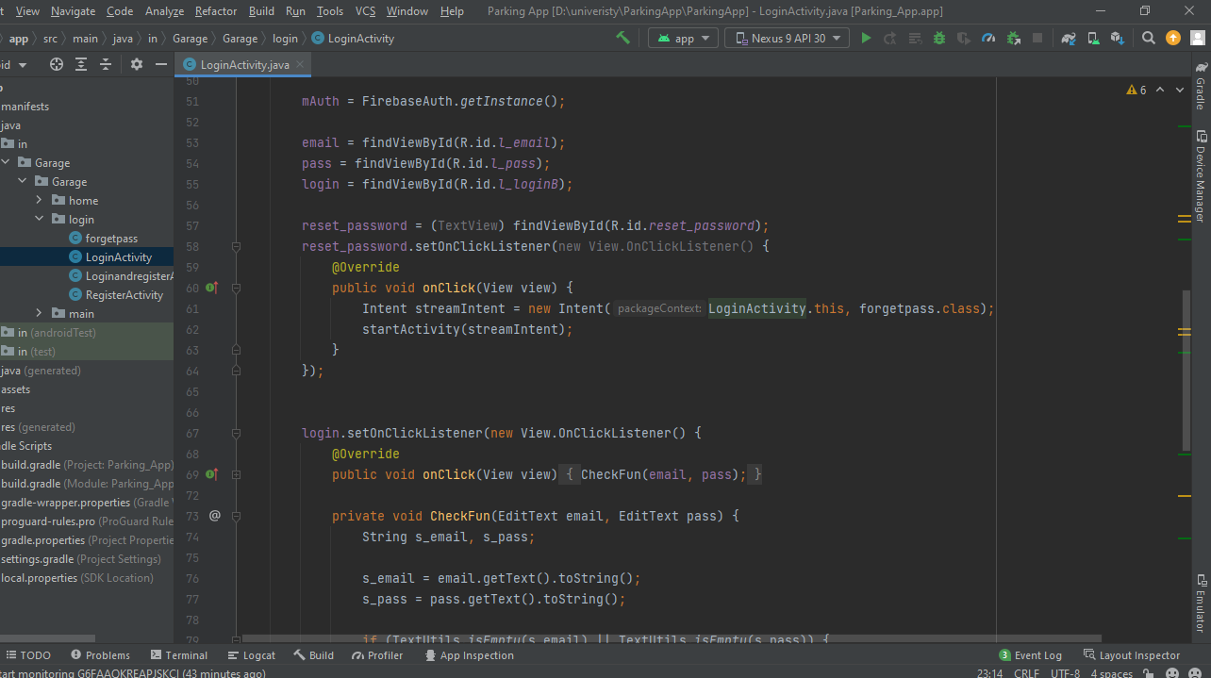

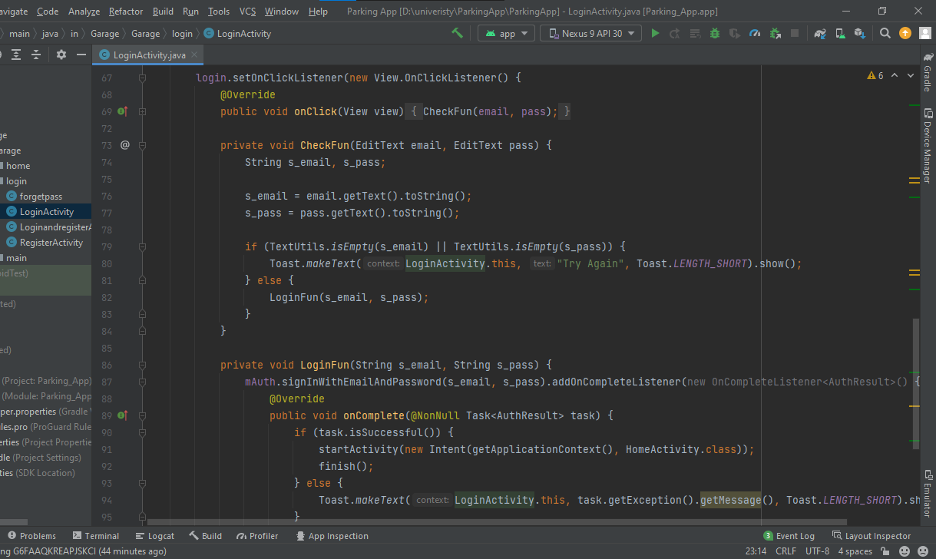

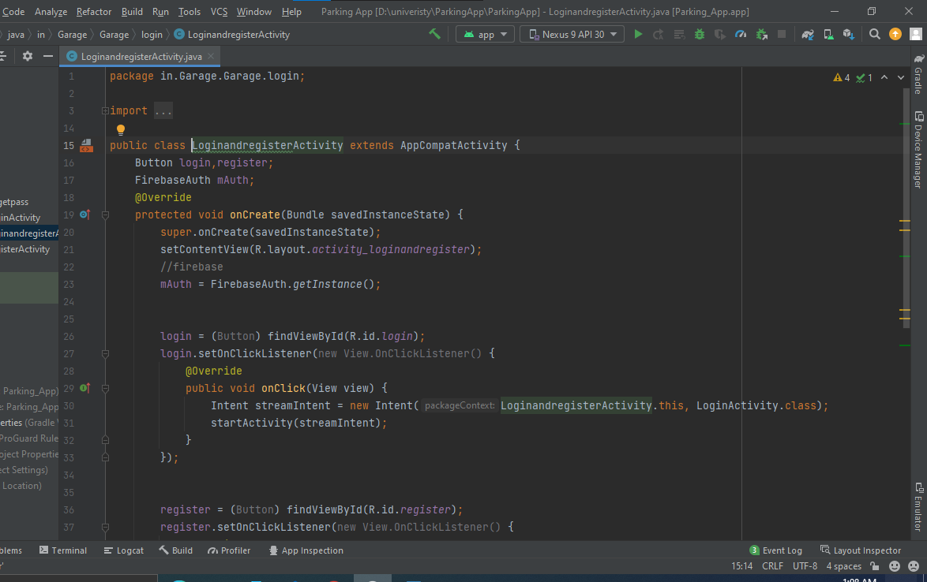

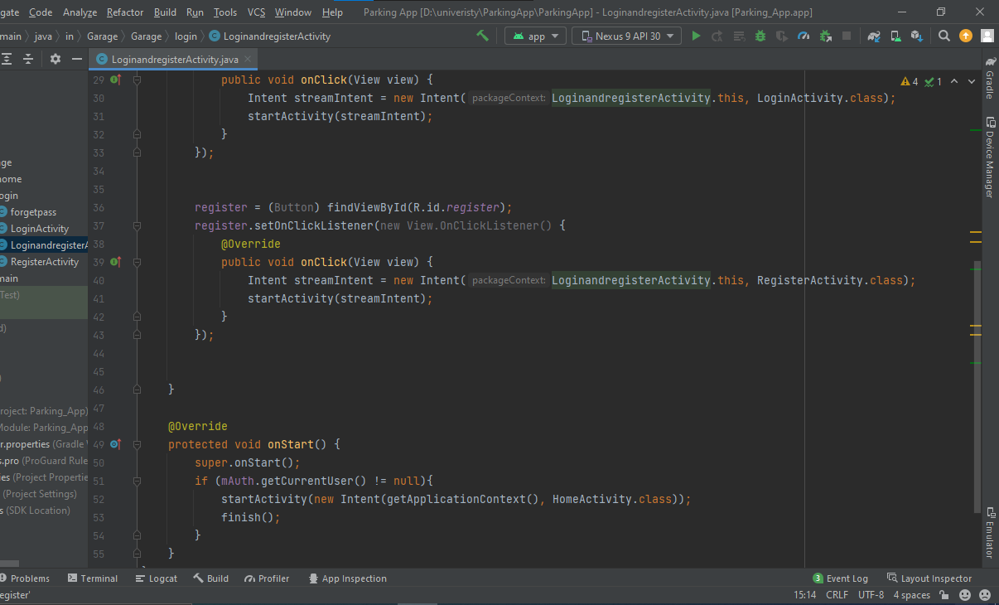

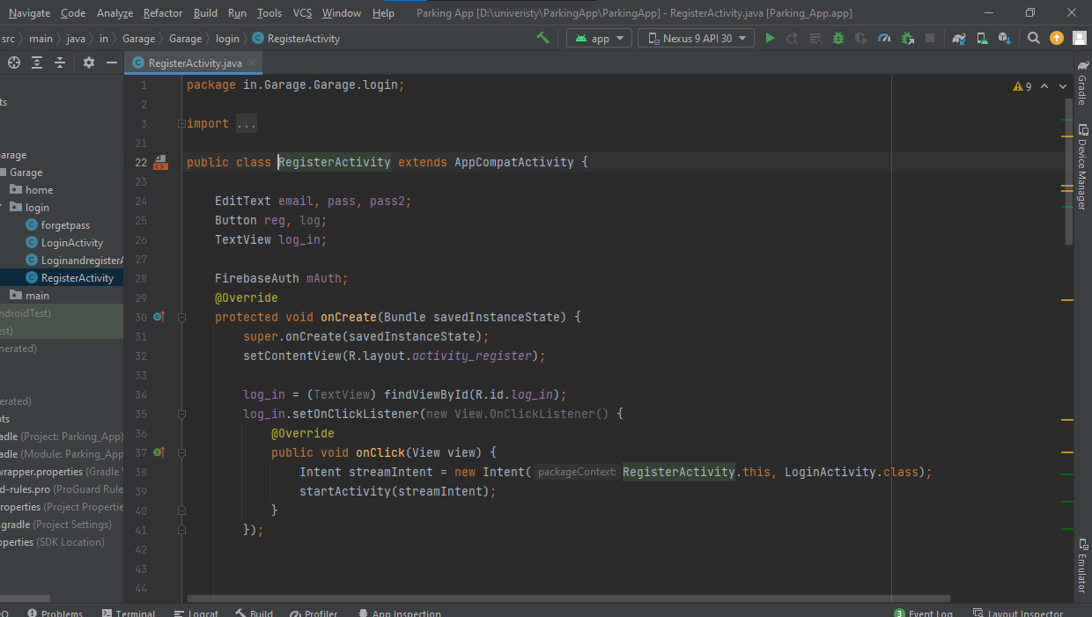

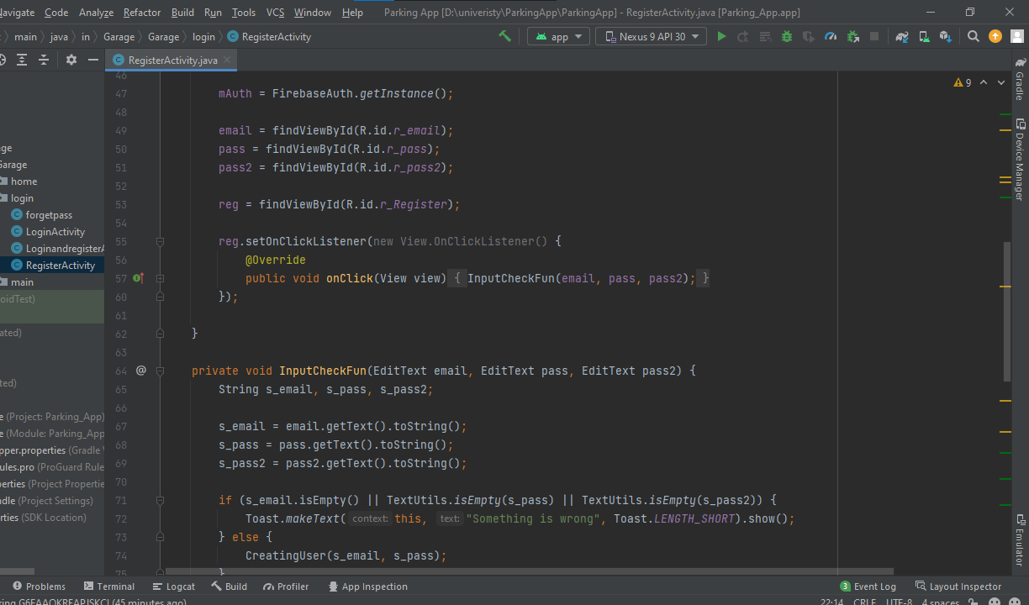

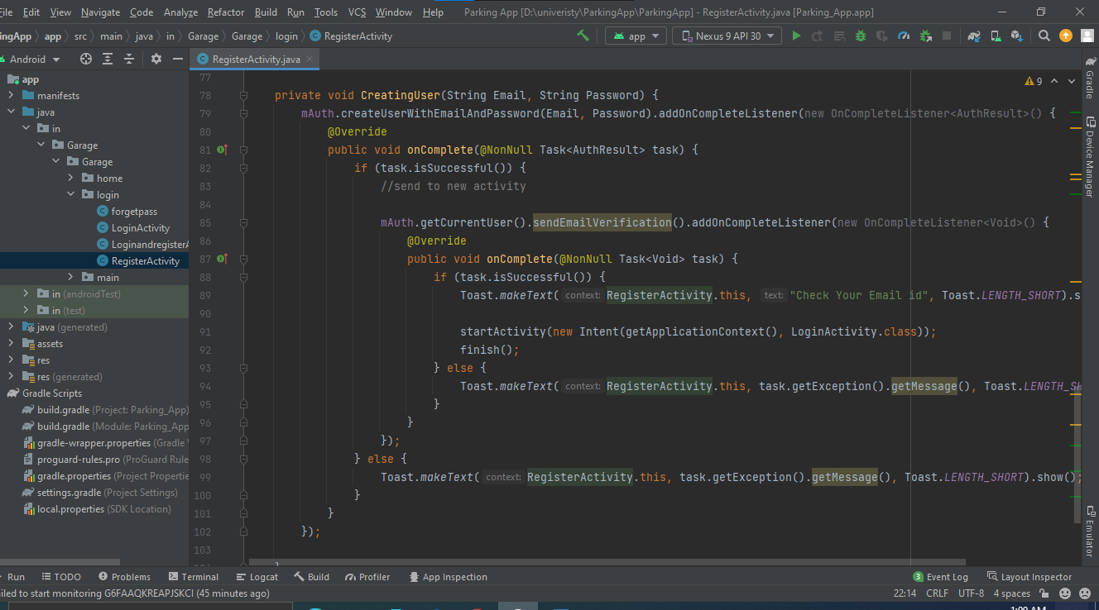

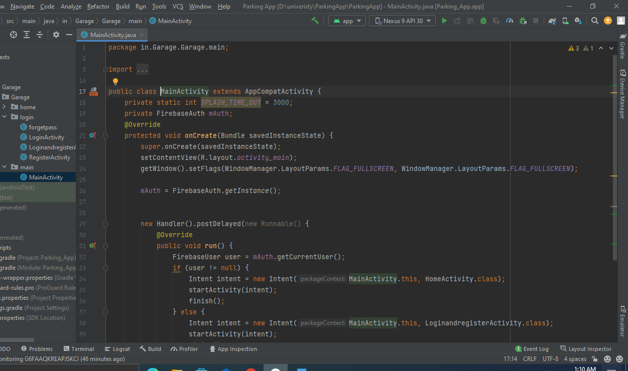

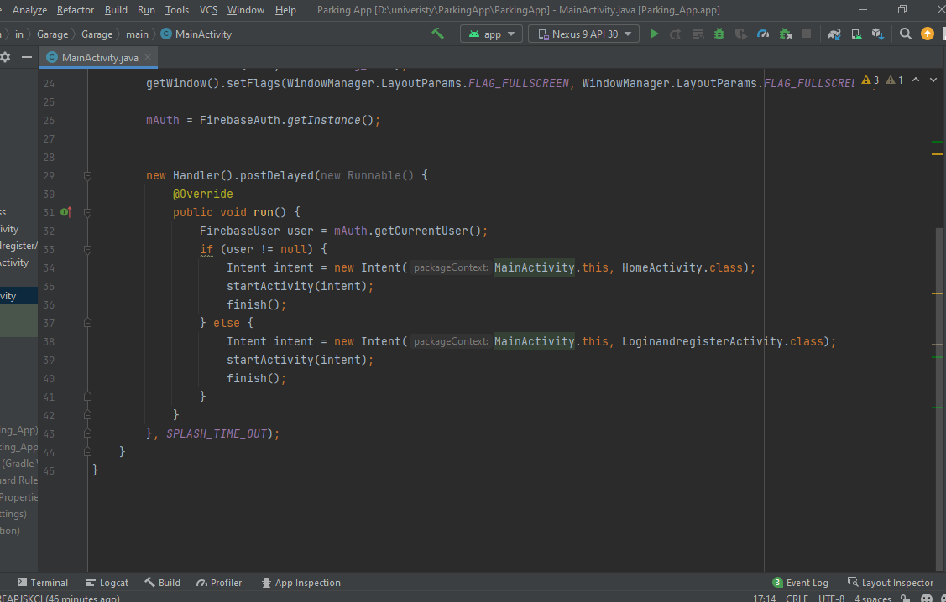

**Application firebase data save:**

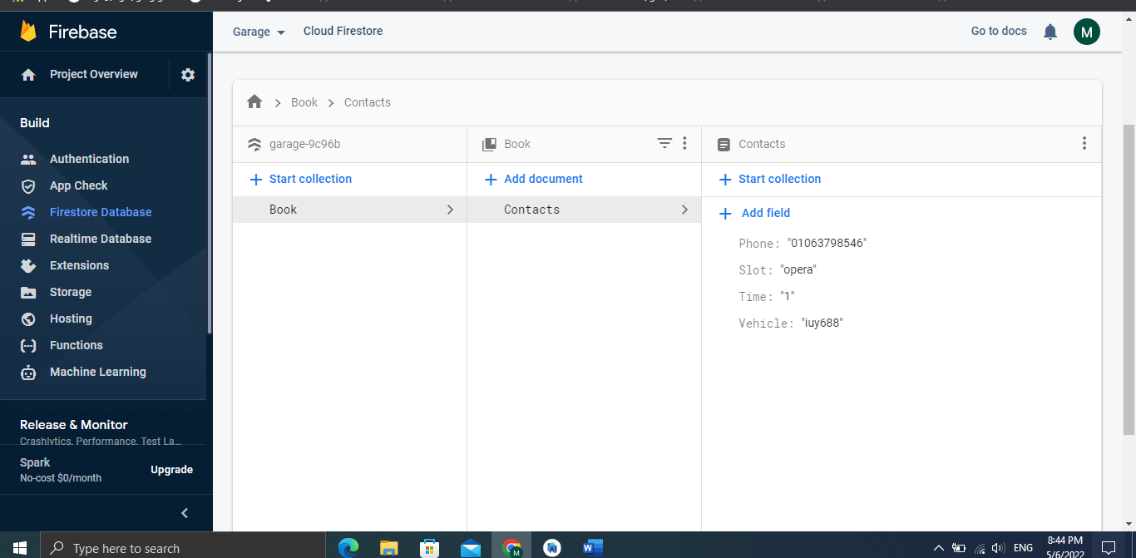

**All (.XML) and (URL) files design that to be easy to the user in his experiment**

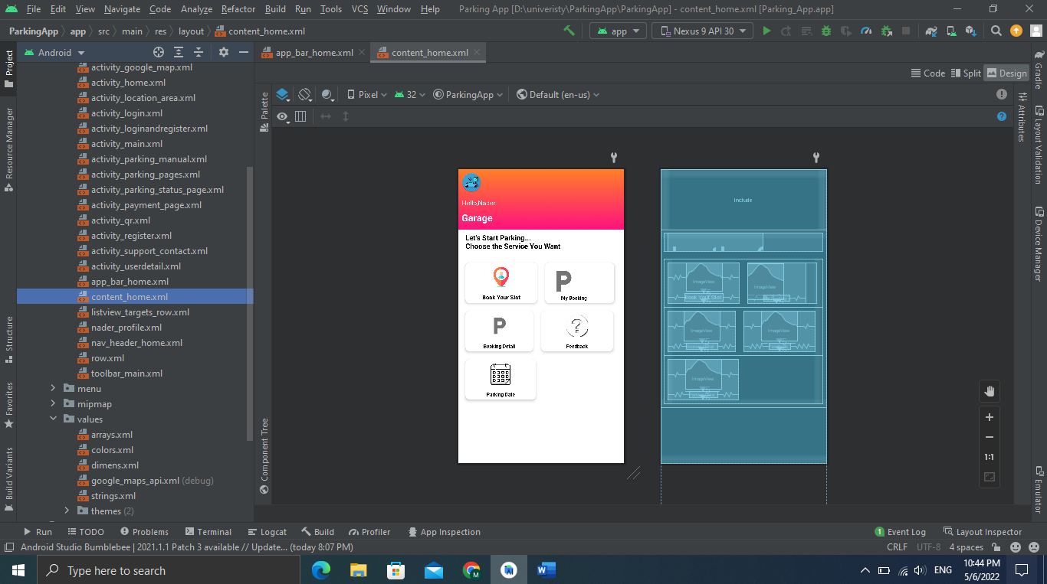

**Chapter 5: Results and discussion**

5.1 **Introduction**

The main purpose of this chapter is to test and also evaluate the Smart Parking System. The evaluation of the system will be done in order to find out if the users’ requirements are met or not.

To find out if the users expectations matches the system’s structure, the usability and functionality of the Smart Parking System will have to be examined. In this chapter, various strategies, methodologies and results will be elaborated.

**5.2 Strategy of evaluation**

The strategy used for the evaluation of the Smart Parking System was to test the functionality, usability and the reliability of the system. The process of evaluating the usability of the system was to discover the struggles faced by users while using the Smart Parking System. The process of evaluating the functionality of the system was to find out if the system meets the users’ expectations.

**5.3 Methods of evaluation**

The choice of methodology used to evaluate the Smart Parking System depends on the type of users that were involved with the evaluation by performing various tasks on the system. The methodology such as observation, users’ opinions, questionnaires and surveys. The observation method was performed while users were performing various tasks within the system, the administrator was observed them and took notes on the usability of the system. Users’ opinion was performed by collecting feedbacks from users after they finished performing their tasks on the system. The questionnaires were given to all the users after using the system. The questionnaire was based on: the usability, functionality and the design of the system. These evaluations helped in finding out whether the system meets the expected performance and also the users’ satisfaction with the system.

**5.4 Android application evaluation**

During the evaluation process of the Smart Parking System android application, users were asked to achieve different tasks. Firstly, users were asked to check the design and layout of the application. Then to browse through the application to check if they were able to view the list of parking slots on the main activity. Then users were asked to book for a parking by providing their correct details. After booking, users were asked to check their email if they received a confirmation email. After which, users were asked to return to the main activity to check if the slot they picked has turned red on the list.

**5.5 Android application questionnaire**

**Question 1-** Was the information on the application relevant and helpful? Yes No If no, tell us what is expected?

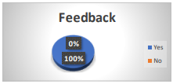

**Question 2-** Was the providing relevant data about the parking? Yes No If no, tell us what is expected?



**Question 3-** Were the links placed in a correct place? Yes No If no, tell us what is expected?



**Question 4-** Was the layout of the application good enough? Yes No If no, tell us what is expected?



**Question 5-** Were you satisfied with the font size? Yes No If no, tell us what is expected?

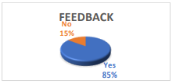

**5.6 Results Evaluation**

Looking at the results from users, it shows that the evaluation differs from users’ opinions and also reflection on the Smart Parking System. users agreed that the Main Page contained useful information, easy to understand and was also straight forward. Everyone seen satisfied with the overall layout. when evaluating the system android application, users were satisfied with the whole process, some users had problems with the font size. When evaluating the parking, users requested that the layout of the parking should be changed due to the fact parking slots were too close to each other which made it difficult for cars to park. Overall, users were satisfied with the way the system links three different technology. Some of the users provided ways of which the Smart Parking System could be improved.

**5.7 Future Application**

Software based on Artificial Intelligent is becoming applied all over as technology is being improved on a daily basis. Methods to use real-time leaning are being used all around. Algorithms that help in real time data processing together with learning processes are being use and when it comes to parking related technologies, self-park vehicles, speech parking; sensor based parking and robotic parking are being used so as to improve our lives on a daily basis. Successful development and findings of the proposed project will be utilized to further car parking studies on which the focus will be more on self-parking vehicles based on the location of the vehicle. The main aim of the further study be to have a deeper understanding on how technology can improve the life style of human beings even with the cars we drive on a daily basis. So far, some research done in the literature review indicates that due to limited space within the parking, most parking may have the tendency of expanding their space which will result to a setup of small parking slots just to accommodate enough cars. Therefore, drivers may have difficulties to getting down the vehicle once they have parked. An implementation of a self-parking vehicle will make their lives easy by allocating an available slot and just going to park there without the aid of a driver.

**Chapter 6 Conclusions**

The objectives of this work were to study the short comings drivers in Cairo area faces and also to validate whether a smart parking system could address these short comings. It was intended that a smart parking system would be designed, implemented and deployed at Cairo area, with the aim of identifying the challenges such a system would face. The objectives were formulated into three

research questions:

1. What are the challenges associated with parking in Area?

2. What are the advantages of smart Parking in Area?

3. What are the challenges a Smart Parking system for Area would face?

* The research questions were answered and a smart parking system was designed.
* Several challenges associated with parking in area were highlighted by researches.
* All the participants believed that the smart parking system could solve their city parking difficulties.
* However, the cost of using a smart parking system also appeared to be a deciding factor to whether or not use the system.
* The preliminary research through interviews identified three main problem areas associated with parking area.

1. Finding parking space.
2. Paying parking fees.
3. Costing of parking time.

Smart Parking System is a solution to the existing traffic congestion, to reduce drivers’ frustration by providing information about the occupancy status of the parking spaces. The project development went smoothly while teaching me many best practices in programming using the current trending technologies like I could see that all the initial requirements of the project are achieved and I tried doing minor data analysis on the parking spaces occupancy statuses.

The android application is user friendly; any user can easily find the status (vacant/occupied) of the parking space and also can set the required date to see the parking history. Starting from coming up with project idea, understanding the requirements and choosing the best technologies for the implementation, all this gave me very good experience and exposure in development of an android application. Upon completing this project successfully, I got familiar with android studio, IDE Shortcuts, Database tools.

**References:**

* Ahmad, N.A.N. and Zamri, S.A.S., 2014, September. The cross platform application development adapted Spring framework to support front-end tendering services. In Computer, Communications, and Control Technology (I4CT), 2014 International Conference on (pp. 58-62). IEEE.
* Alarcon, R. and Wilde, E., 2010, April. Linking data from restful services. In Third Workshop on Linked Data on the Web, Raleigh, North Carolina (April 2010).
* Al-Fagih, A.E., Al-Turjman, F.M., Alsalih, W.M. and Hassanein, H.S., 2013. A priced public sensing framework for heterogeneous IoT architectures. Emerging Topics in Computing, IEEE Transactions on, 1(1), pp.133-147.
* Alpaydin, E., 2014. Introduction to machine learning. MIT press.
* Anthes, G., 2012. HTML5 leads a web revolution. Communications of the ACM, 55(7), pp.16-17.
* Armando, A., Carbone, R., Chekole, E.G. and Ranise, S., 2014, June. Attribute based access control for APIs in spring security. In Proceedings of the 19th ACM symposium on Access control models and technologies (pp. 85-88). ACM.
* Atighetchi, M., Soule, N., Pal, P., Loyall, J., Sinclair, A. and Grant, R., 2013, October. Safe configuration of TLS connections. In Communications and Network Security (CNS), 2013 IEEE Conference on (pp. 415- 422). IEEE.
* Bormann, C., Castellani, A.P. and Shelby, Z., 2012. Coap: An application protocol for billions of tiny internet nodes. IEEE Internet Computing, 16(2), p.62.
* Centenaro, M., Vangelista, L., Zanella, A. and Zorzi, M., 2015. Long-Range Communications in Unlicensed Bands: The Rising Stars in the IoT and Smart City Scenarios. arXiv preprint arXiv:1510.00620.
* Chinrungrueng, J., Sunantachaikul, U. and Triamlumlerd, S., 2007, January. Smart parking: An application of optical wireless sensor network. In Applications and the Internet Workshops, 2007. SAINT Workshops 2007. International Symposium on (pp. 66-66). IEEE.